
Module Code | : | CT050-3-2-WAPP – Web Applications
Intake Code | : | APD2F2509CS(CYB)
Lecturer Name | : | Mr. WONG CHUNG WEI
Hand in Date | : | Monday, 23rd February 2026, Week 1
Hand out Date | : | 31st May 2026, Week 13
Group No. | : | Group 3
Group Leader | : | SULTAN ABDULLA OMAR TAKRORI
Project Title | : | HACKLAB ACADEMY

Student ID | Student Name
TP085327 | SULTAN ABDULLA OMAR TAKRORI
TP084807 | AHMED MIRAHUSAIN ALVI
TP084446 | ALAA AHMED MOHAMED ABDELHAI
TP082459 | MOHAMED ABDIFATAH ALI

TABLE OF CONTENTS

CHAPTER 1: INTRODUCTION 4
1.1 Overview 4
1.2 Project Goal or Aim (Mission Statement) 4
1.3 Objectives 5
1.4 Scope of Work 5
CHAPTER 2: STORYBOARD & DESIGN DOCUMENTS 6
2.1 Audience Modelling 6
2.2 Use Case Diagram 7
2.3 Use Case Diagram Specification 8
2.3.1 View Website 8
2.3.2 Register 9
2.3.3 Manage System Database (CRUD) 10
2.3.4 Login 11
2.3.5 Forget Password 12
2.3.6 Validate User Credentials 13
2.3.7 View Labs / Course Modules 14
2.3.8 Attempt Quizzes 15
2.3.9 Track Learning Progress 16
2.4 Major Functions of the Web 17
2.4.1 Public Guest Module 17
2.4.2 Authenticated Member Module 17
2.4.3 Enterprise Administrator Module 17
CHAPTER 3: DESIGN AND MODELING 19
3.1 Entity Relationship Diagram (ERD) 19
3.2 Wireframes 20
3.2.1 Home page 20
3.2.2 About Us Page 20
3.2.3 Contact Us page 21
3.2.4 Labs page 21
3.2.5 Member Dashboard Page 22
3.2.6 Browse Labs Page 22
3.2.7 My Reviews Page 23
3.2.8 Admin Dashboard Page 23
3.2.9 Add Labs Page 24
3.2.10 Edit Room Content Page 24
3.3 Website Navigational Structure 25
CHAPTER 4: IMPLEMENTATION 26
4.1 Front-end CSS 26
4.1.1 The :root block 26
4.1.2 Login and Registration Page Layouts 27
4.1.3 Client-side JavaScript (Light-mode / Dark-mode) 28
4.1.4 Contact Page Layout 28
4.2 Form Validation 29
4.2.1 Registration.aspx 29
4.2.2 Login.aspx 30
4.2.3 ForgetPassword.aspx 31
4.3 SQL Queries 32
4.3.1 Web.config 32
4.3.2 Core Execution Helpers 33
4.3.3 User Management SQL queries 35
CHAPTER 5: USER GUIDANCE 39
5.1 Homepage - Home.aspx 39
5.2 About Us Page – About.aspx 39
5.3 Contact Us Page – Contact.aspx 40
5.4 Registration Page – Register.aspx 40
5.5 Login Page – Login.aspx 41
5.6 Password Reset Page – ForgetPassword.aspx 41
5.7 Member Dashboard Page – MemberDashboard.aspx 42
5.8 Reverse Engineering Lab - ReverseEngineeringLab.aspx 42
5.9 Cryptography Lab – Cryptography.aspx 43
5.10 Admin Dashboard page – AdminDashboard.aspx 43
5.11 Add / Publish Lab page 44
5.12 Published Labs page 44
5.13 Edit Room Content page 45
5.14 Recent Member Logins 45
5.15 View Lab Reviews page 46
5.16 Contact Messages page 46
CONCLUSION 47
REFERENCES 48
APPENDIX: PROPOSAL REPORT 49
WORKLOAD MATRIX 50

CHAPTER 1: INTRODUCTION

1.1 Overview
Hack Lab Academy is a web-based cybersecurity learning platform developed to provide students and beginners with practical and interactive cybersecurity education. The platform focuses on ethical hacking, Capture The Flag (CTF) challenges, and virtual lab activities that help users improve their technical and problem-solving skills in a controlled learning environment.
The purpose of this project is to create an accessible and user-friendly learning platform that supports cybersecurity education through structured course materials, practical exercises, and interactive learning tools. As cybersecurity threats continue to increase globally, the platform plays an important role in helping learners develop awareness and hands-on technical skills safely and ethically.
The expected benefits of Hack Lab Academy include providing students with flexible self-learning opportunities, supporting educators in delivering cybersecurity-related content, and encouraging collaborative learning through discussions, quizzes, and virtual labs. The platform also aims to improve users’ practical understanding of cybersecurity concepts such as web security, cryptography, forensics, and reverse engineering.

1.2 Project Goal or Aim (Mission Statement)
The goal of Hack Lab Academy is to develop a web-based cybersecurity learning platform that provides structured educational content, virtual labs, and ethical hacking exercises for students, beginners, and self-learners. The platform focuses on cybersecurity topics such as cryptography, reverse engineering, and Capture The Flag (CTF) challenges. Its purpose is to create a safe and interactive learning environment where users can improve their cybersecurity knowledge and practical skills through guided activities and role-based learning features.

1.3 Objectives
- To conduct a preliminary and feasibility study for the development of Hack Lab Academy.
- To gather information about user requirements, cybersecurity learning needs, and system functionality.
- To analyze the technical and functional requirements of the platform, including security, usability, and accessibility.
- To construct requirement models and define user roles, system processes, and database requirements.
- To design the website interface, system architecture, navigation structure, and database model.
- To build and develop the platform using HTML5, CSS, JavaScript, ASP.NET, and MS SQL database technologies.
- To implement features such as login systems, course modules, quizzes and virtual labs
- To evaluate and test the system for functionality, usability, security, and overall performance.
- To maintain and improve the platform through updates, technical support, and content management.

1.4 Scope of Work
- Website features include user registration and login systems, cybersecurity course modules, virtual labs, quizzes, progress tracking, and lab reviews.
- Content types include articles, video tutorials, lab exercises and quizzes.
- User roles include administrators, guests, and members with different access permissions and responsibilities.
- The technologies used for development include HTML5, CSS3, JavaScript, ASP.NET, MS SQL Server, and IIS for web hosting and database connectivity.
- The platform will support role-based authentication, CRUD operations, secure database management, and responsive web design for accessibility across devices.

CHAPTER 2: STORYBOARD & DESIGN DOCUMENTS

2.1 Audience Modelling
Hack Lab Academy is designed for cybersecurity students, beginners, and self-learners who want to gain practical knowledge and hands-on experience in ethical hacking and cybersecurity concepts. The platform also supports educators and trainers who require structured teaching materials and virtual lab environments for cybersecurity education.
User Type | Profile / Characteristics | Needs and Goals
Cybersecurity Students | University or college students studying cybersecurity, IT, or computer science. Usually aged between 18–25 with basic technical knowledge. | Need practical cybersecurity training, lab exercises, quizzes, and learning resources to improve academic and technical skills.
Beginners | New users with little or no cybersecurity background who are interested in learning ethical hacking and online security concepts. | Need simple explanations, beginner-friendly tutorials, guided labs, and easy navigation to support learning.
Self-Learners | Independent learners or working professionals who want to improve their cybersecurity knowledge through self-study. | Need flexible access to learning materials, structured courses, and practical challenges that can be completed at their own pace.
Educators / Trainers | Lecturers, instructors, or trainers responsible for teaching cybersecurity-related subjects. | Need organized teaching materials, student management tools, quizzes, assignments, and virtual lab support for effective teaching.
Administrators | System managers responsible for maintaining and managing the platform content and users. | Need full control over users, course modules, categories, and website maintenance through secure administrative tools.

2.2 Use Case Diagram
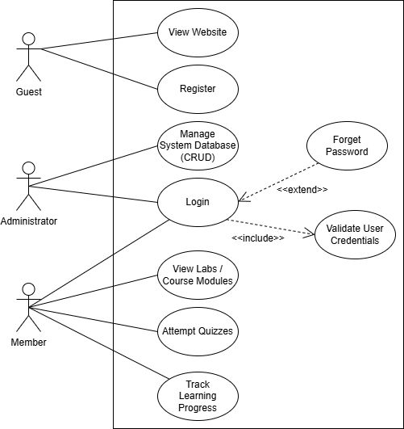
Figure 1 HackLab Academy Use Case Diagram

2.3 Use Case Diagram Specification

2.3.1 View Website
USE CASE | VIEW WEBSITE
Brief Description | This use case allows an unregistered visitor (Guest) to open the HackLab Academy homepage and browse public information.
Actors | Guest
Preconditions | The user has a web browser and active internet access.
Main Flow | (a) The use case begins when the user types the website URL into their browser.  (b) The system loads the homepage using clean front-end CSS layouts .  (c) The system displays an introductory overview of platform features and cybersecurity topics.
Alternative Flows | (a) The website fails to load due to a server issue. The system displays a friendly error page and asks the user to refresh.
Postconditions | The user successfully views the public homepage on their device.

2.3.2 Register
USE CASE | REGISTER
Brief Description | This use case allows a Guest to create a new personal student account to gain access to the platform's restricted areas.
Actors | Guest
Preconditions | The user has navigated to the registration page and is not currently logged in.
Main Flow | (a) The use case begins when the user clicks the sign-up or registration link.  (b) The system displays the account registration form .  (c) The user enters their username, email, password, and password confirmation .  (d) The system checks the inputs using real-time form validation .  (e) The system queries the MS SQL database to verify that the email address is not already taken .  (f) The system saves the new user account details into the database .  (g) The system displays a success message and redirects the user to the login page.
Alternative Flows | a) Mandatory fields are left blank or formatted incorrectly. The system highlights the errors, displays an inline warning, and stops the submission.  (b) The entered email matches an existing account. The system warns the user that the email is taken and requests a different one.
Postconditions | A unique user profile is successfully created and stored in the database registry.

2.3.3 Manage System Database (CRUD)
USE CASE | MANAGE SYSTEM DATABASE (CRUD)
Brief Description | This use case allows the administrator to create, view, update, and delete learning content or user records directly within the database.
Actors | Administrator
Preconditions | The administrator is securely logged in with valid admin privileges.
Main Flow | (a) The use case begins when the administrator opens the secure admin dashboard portal .  (b) The system retrieves the current user data and course modules from the MS SQL database to display them on screen .  c) The administrator selects the type of action they want to perform: Insert, Update, or Delete .  (d) The administrator fills out or modifies data using the provided dashboard forms .  (e) The administrator clicks to save and confirm the changes.  (f) The system securely processes the parameterized SQL queries against the server.
Alternative Flows | (a) The admin enters values that violate data rules or formatting constraints. The system blocks the changes and displays an error message.  (b) A database connection error occurs mid-transaction. The system cancels the action safely and alerts the admin to retry.
Postconditions | The database state is updated successfully, making the changes visible platform-wide.

2.3.4 Login
USE CASE | LOGIN
Brief Description | This use case verifies a user's identity credentials to start an authenticated session for Members and Administrators.
Actors | Registered Member, Platform Administrator
Preconditions | The user has an active account and is currently viewing the login page.
Main Flow | (a) The use case begins when the user opens the login interface .  (b) The system displays the credential email and password input fields.  (c) The user enters their email and password into the login form.  (d) The system triggers the internal use case Validate User Credentials to verify the inputs.  (e) The system checks the user's assigned role and creates an active session state .  (f) The system redirects the user to their designated student or administrative dashboard screen.
Alternative Flows | (a) Input fields are left empty. The system stops the login attempt and displays a reminder message.  (b) The credentials do not match any recorded account. The system displays an invalid login message and requests a retry.  (c) The user clicks the "Forgot Password" link. The system opens up the separate Forget Password recovery flow.
Postconditions | The database state is updated successfully, making the changes visible platform-wide.

2.3.5 Forget Password
USE CASE | LOGIN
Brief Description | This use case verifies a user's identity credentials to start an authenticated session for Members and Administrators.
Actors | Member, Administrator
Preconditions | The user has an active account and is currently viewing the login page.
Main Flow | (a) The use case begins when the user opens the login interface .  (b) The system displays the credential email and password input fields.  (c) The user enters their email and password into the login form.  (d) The system triggers the internal use case Validate User Credentials to verify the inputs.  (e) The system checks the user's assigned role and creates an active session state .  (f) The system redirects the user to their designated student or administrative dashboard screen.
Alternative Flows | (a) Input fields are left empty. The system stops the login attempt and displays a reminder message.  (b) The credentials do not match any recorded account. The system displays an invalid login message and requests a retry.  (c) The user clicks the "Forgot Password" link. The system opens up the separate Forget Password recovery flow.
Postconditions | The database state is updated successfully, making the changes visible platform-wide.

2.3.6 Validate User Credentials
USE CASE | VALIDATE USER CREDENTIALS
Brief Description | This internal process automatically checks user login form inputs against the saved backend data entities.
Actors | Member, Administrator
Preconditions | This background system step is automatically called whenever the main Login use case runs.
Main Flow | (a) The use case begins when the system captures the email and password inputs from the login form.  (b) The system runs an internal SQL search statement using the provided email.  (c) The server retrieves the matching password string from the secure database tables.  (d) The system evaluates the inputs against the database records to check if they match.  (e) The system returns a true/false verification result back to the main login processing loop.
Alternative Flows | (a) No database record matches the provided email. The system passes a failure flag back to the main login handler.
Postconditions | Account correctness flags are calculated and sent securely back to the core system engine.

2.3.7 View Labs / Course Modules
USE CASE | VIEW LABS / COURSE MODULES
Brief Description | This internal process automatically checks user login form inputs against the saved backend data entities.
Actors | Member, Administrator
Preconditions | This background system step is automatically called whenever the main Login use case runs.
Main Flow | (a) The use case begins when the system captures the email and password inputs from the login form.  (b) The system runs an internal SQL search statement using the provided email.  (c) The server retrieves the matching password string from the secure database tables.  (d) The system evaluates the inputs against the database records to check if they match.  (e) The system returns a true/false verification result back to the main login processing loop.
Alternative Flows | (a) No database record matches the provided email. The system passes a failure flag back to the main login handler.
Postconditions | Account correctness flags are calculated and sent securely back to the core system engine.

2.3.8 Attempt Quizzes
USE CASE | ATTEMPT QUIZZES
Brief Description | This use case allows logged-in students to answer knowledge-check questions to test their cybersecurity understanding.
Actors | Registered Member
Preconditions | The student is logged into the platform and clicks on an active quiz module container.
Main Flow | (a) The use case begins when the user clicks the button to start a quiz challenge .  (b) The system loads the required question datasets and multiple-choice answers from the database tables.  (c) The system displays the quiz questions on screen for the user to answer .  (d) The user completes the questions and clicks the "Submit Quiz" button.  (e) The system instantly calculates the score and saves the results under the user's profile history.  (f) The interface displays the final score and question review feedback on screen.
Alternative Flows | (a) The user attempts to submit a quiz with unanswered questions. The system halts the submission and highlights the missing answers before allowing them to finish.
Postconditions | Quiz performance results are calculated and successfully updated in the student's log history.

2.3.9 Track Learning Progress
USE CASE | TRACK LEARNING PROGRESS
Brief Description | This use case gathers a student's completion records to display a visual summary of their scores and finished labs.
Actors | Member
Preconditions | The student is securely logged in and opens their personal profile dashboard view.
Main Flow | (a) The use case begins when the user clicks on the progress tracking or dashboard link.  (b) The system requests database information using the current session's unique user ID key.  (c) The database pulls the user's logged history, including quiz scores and completed lab challenges.  (d) The system displays this tracking data on screen using simple, easy-to-read progress layout charts.
Alternative Flows | (a) A brand-new user checks their progress for the first time. The system finds zero history rows and displays a welcome message encouraging them to start their first lab module.
Postconditions | The user's compiled performance and activity metrics display clearly on their account dashboard.

2.4 Major Functions of the Web

2.4.1 Public Guest Module
- Resource Catalog Display: Dynamically renders public introductory content and platform offerings directly from the local database.
- Input-Validated Membership Registration: A secure endpoint capturing user sign-ups. Client-side validation blocks blank entries, and server-side logic checks for pre-existing emails to prevent database duplicate conflicts.

2.4.2 Authenticated Member Module
- Role-Based Login Authentication: Restricts platform interaction by requiring a valid user login session. Session states prevent unauthorized URL browsing to protected directories.
- Interactive Resource Hub: Serves as the interactive framework for students to engage with asynchronous virtual learning objects and review tracked performance metrics.

2.4.3 Enterprise Administrator Module
Database Management Engine (CRUD): Gives the admin structural system control over data records through an isolated interface:
- Create: Insert new digital learning resources or mock lab instances.
- Read: Display real-time telemetry of system users and content inventories.
- Update: Modify existing parameters such as user access privileges or text details.
- Delete: Remove outdated assets or offending profiles safely from the relational tables.

2.5 Process Flow Chart (Guest User Registration)
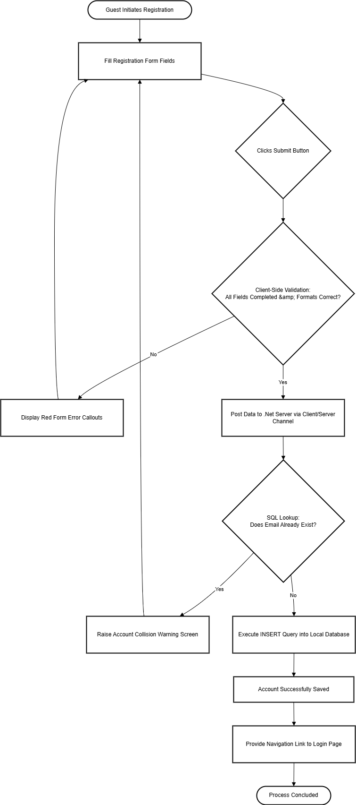
Figure 2 Guest User Registration Process Flow Chart

CHAPTER 3: DESIGN AND MODELING

3.1 Entity Relationship Diagram (ERD)
c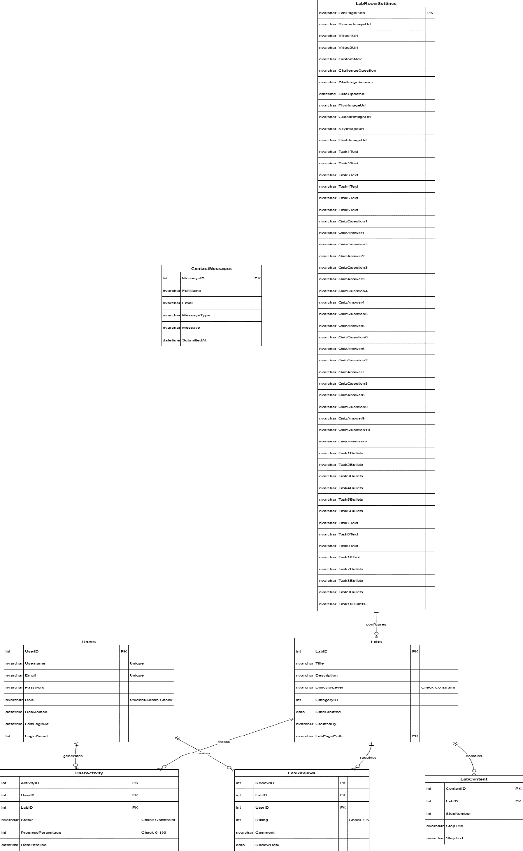
Figure 3 HackLab Academy Database ERD Diagram

3.2 Wireframes

3.2.1 Home page
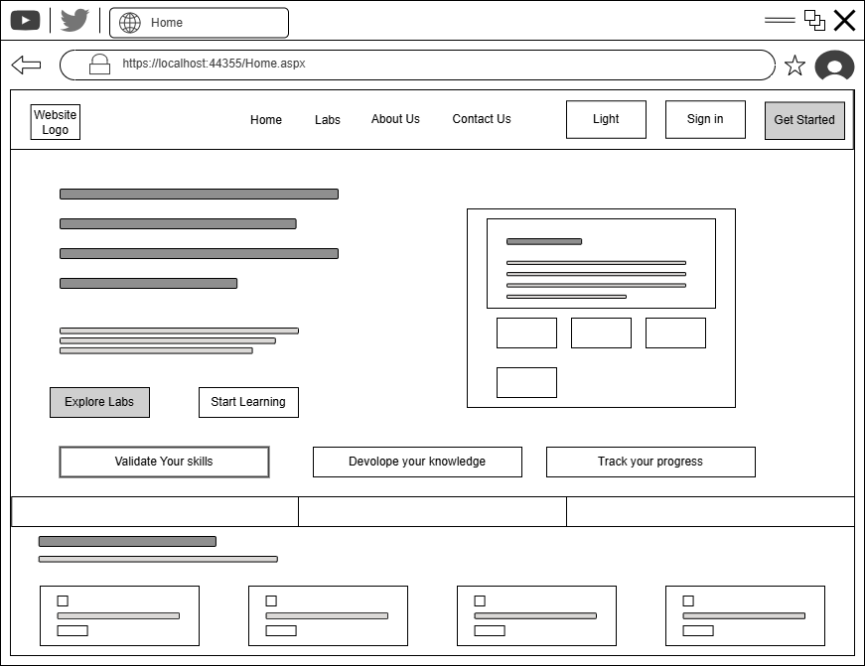
Figure 4 Homepage Wireframe

3.2.2 About Us Page
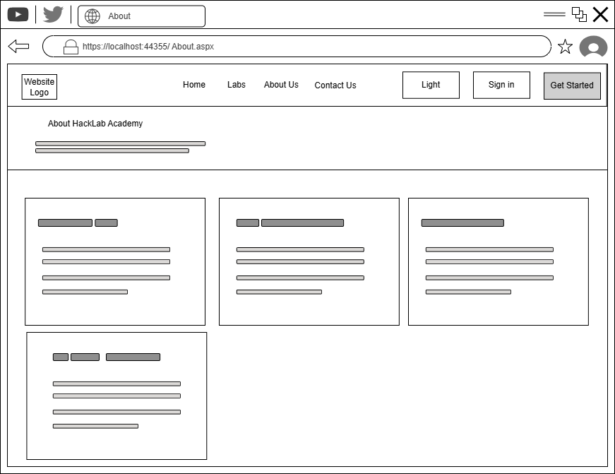
Figure 5 About Us page Wireframe

3.2.3 Contact Us page
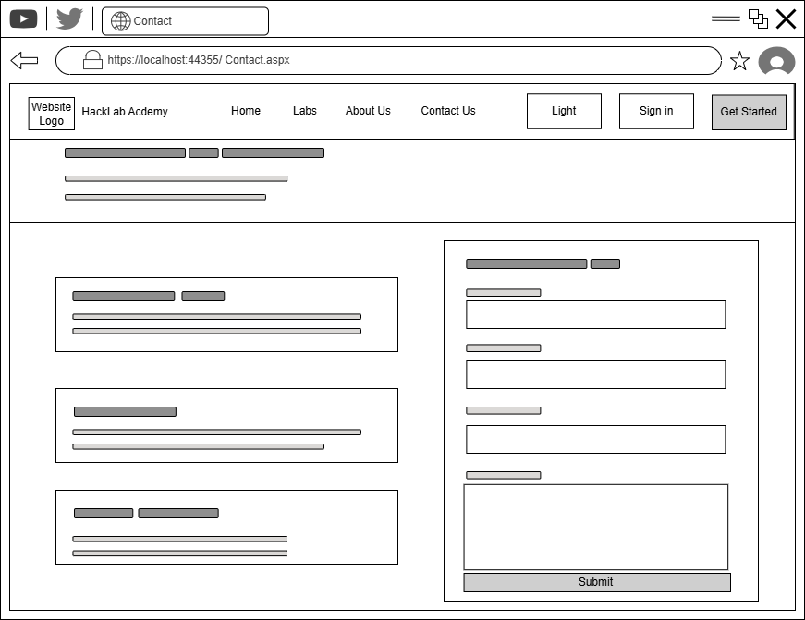
Figure 6 Contact Us page Wireframe

3.2.4 Labs page
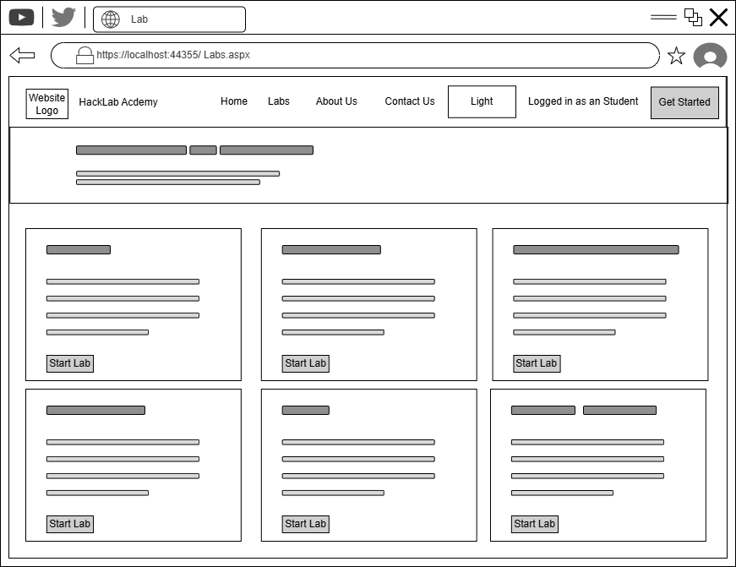
Figure 7 Browse Labs page Wireframe

3.2.5 Member Dashboard Page
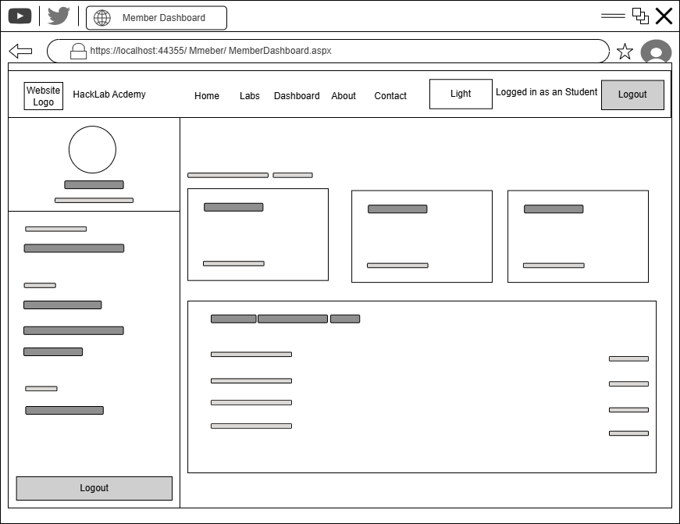
Figure 8 Member Dashboard Wireframe

3.2.6 Browse Labs Page
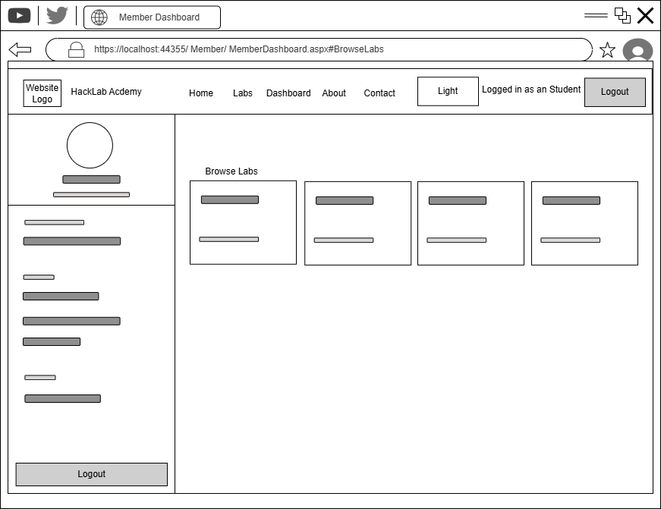
Figure 9 Browse Labs page Wireframe

3.2.7 My Reviews Page
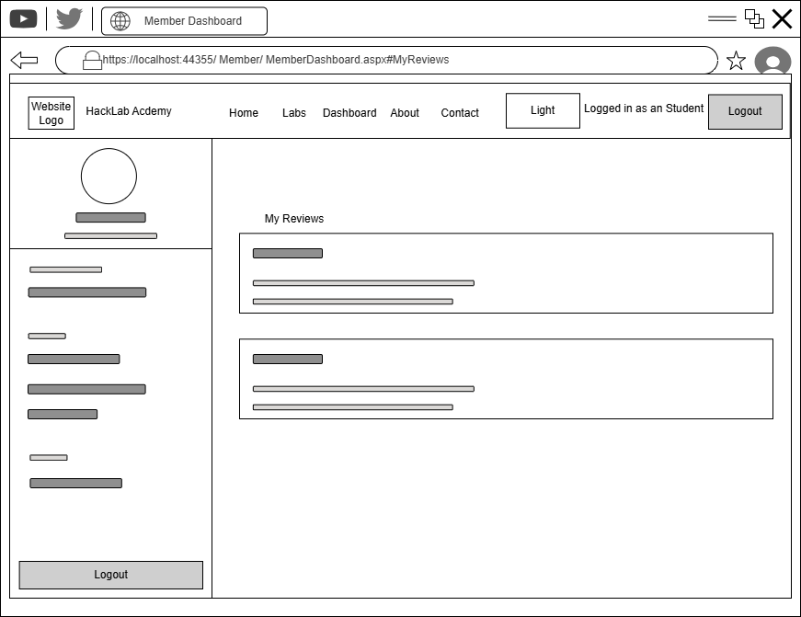
Figure 10 My Reviews page Wireframe

3.2.8 Admin Dashboard Page
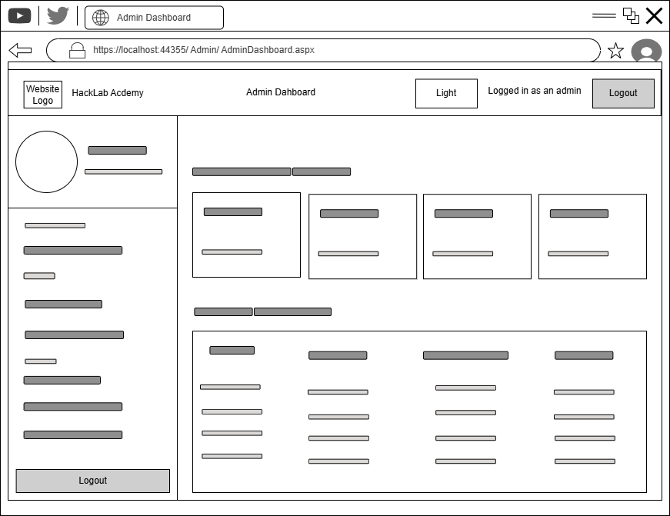
Figure 11 Admin Dashboard Wireframe

3.2.9 Add Labs Page
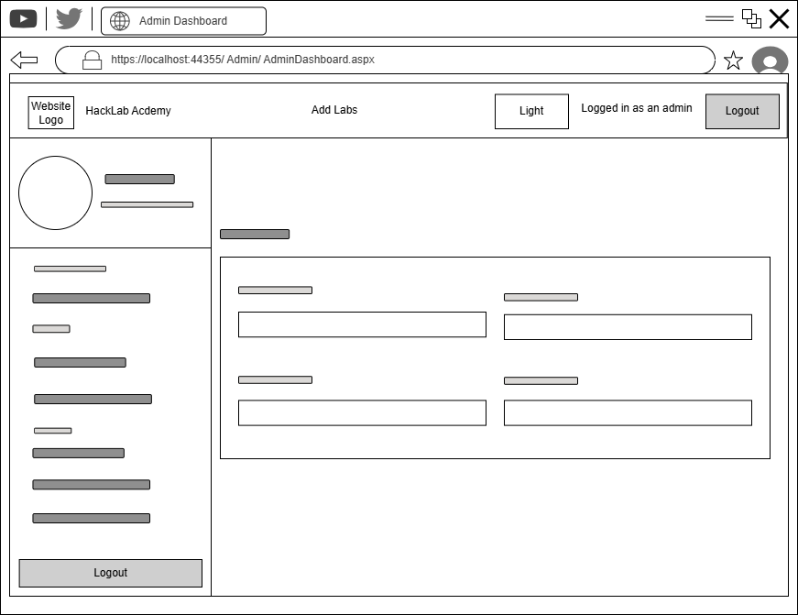
Figure 12 Add Labs page Wireframe

3.2.10 Edit Room Content Page
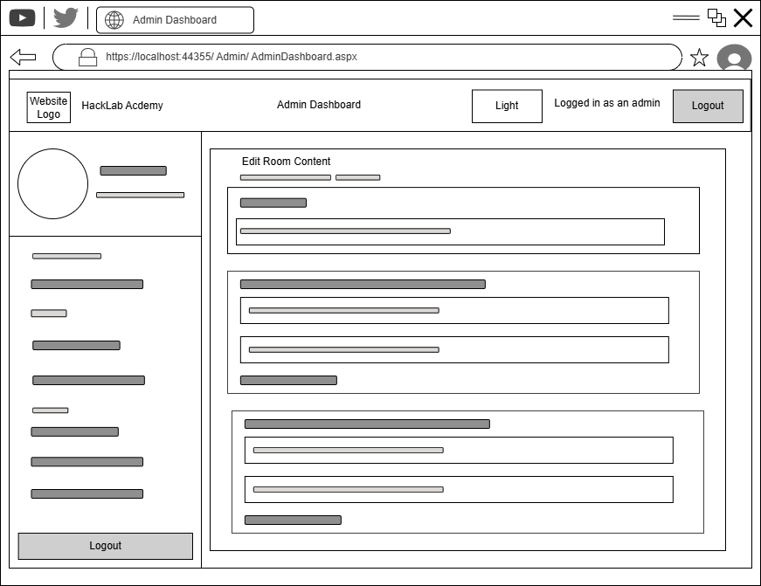
Figure 13 Edit Room Content Page Wireframe

3.3 Website Navigational Structure
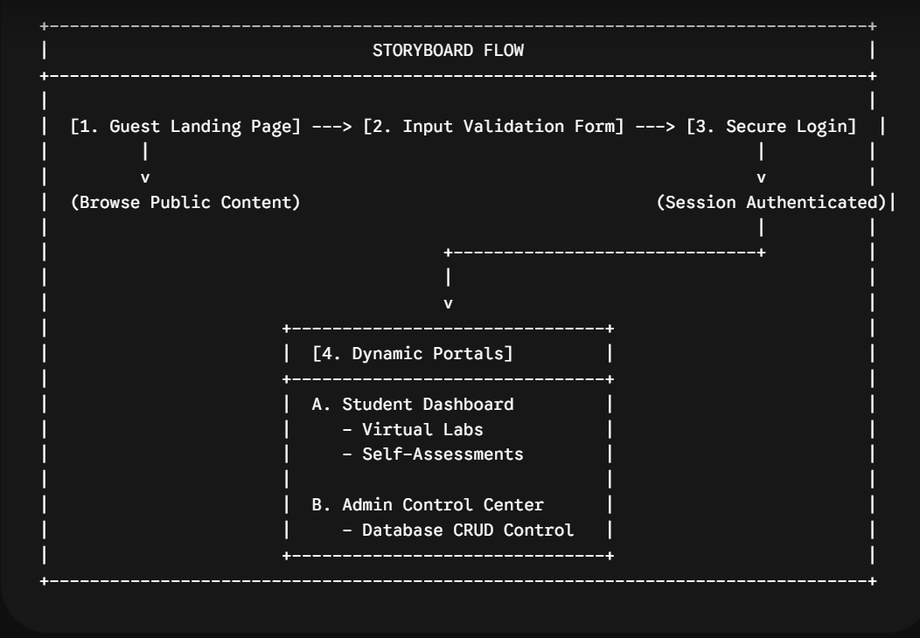
Figure 14 Hack Lab Academy Website Navigational Structure
- A visitor lands on the dark-themed homepage and clicks "Join Now" to redirect to the registration portal.
- The user submits their details; client-side JavaScript validates fields in real time to catch errors before injecting valid accounts into the database.
- The member logs in, and the server validates their credentials against hashed database records to grant a secure, role-restricted session.
- Students access a personalized dashboard to launch virtual hacking labs and complete interactive self-assessments.
- Administrators log into a dedicated panel to update, edit, or delete virtual lab scenarios and read Lab reviews given by member users .

CHAPTER 4: IMPLEMENTATION
HackLab Academy is a role-based cybersecurity e-learning platform built on ASP.NET Web Forms (.NET Framework 4.8) with a SQL Server backend. This chapter provides a detailed explanation of the major source-code features, covering CSS page styling, client-side and server-side form validation, and the SQL queries used for database connectivity.
Framework | ASP.NET Web Forms, .NET Framework 4.8
Language | C#, HTML/CSS, JavaScript
Database | SQL Server, ADO.NET SqlClient
Architecture | Centralized Database Helper, Master Page, role-based routing
Key files | DatabaseHelper.cs, site.css, site.js, *.aspx / *.aspx.cs

4.1 Front-end CSS
All visual styling for HackLab Academy is defined in a single global stylesheet: Content/site.css. It uses CSS Custom Properties (variables) as a central design token system, supporting both a dark theme and a user-toggleable light theme.

4.1.1 The :root block
The :root block defines the full color palette and spacing tokens that every component inherits. This makes global re-theming a single-line change.
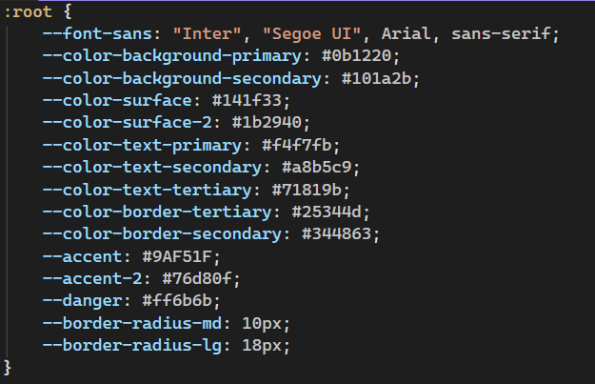
Figure 15 Hack Lab Academy CSS :root block

4.1.2 Login and Registration Page Layouts
The login and registration pages are centered using Flexbox on the .auth-outer wrapper. The .auth-card holds the form, and each field is wrapped in a .fld container that applies consistent label spacing and focus styling.
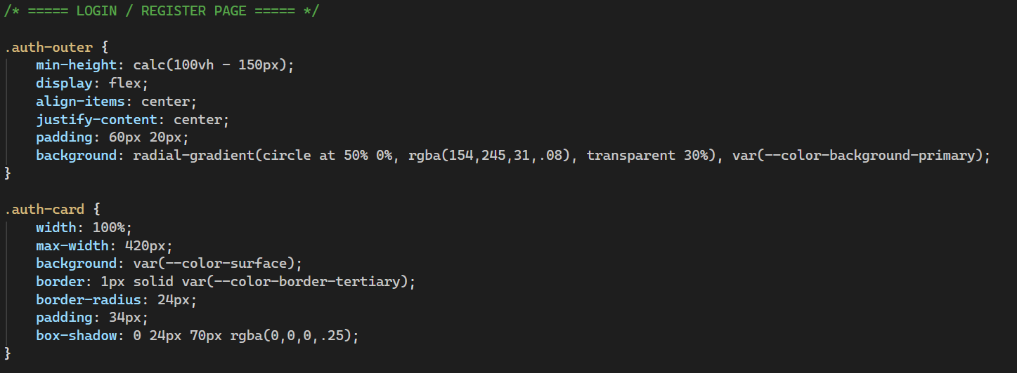
Figure 16 Login / Registration page CSS
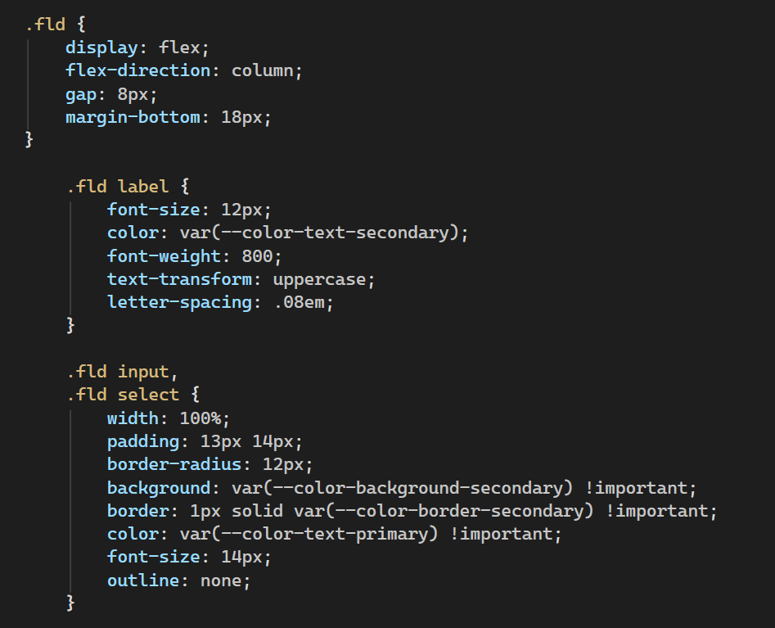
Figure 17 Login / Registration page Flexbox layout alignment

4.1.3 Client-side JavaScript (Light-mode / Dark-mode)
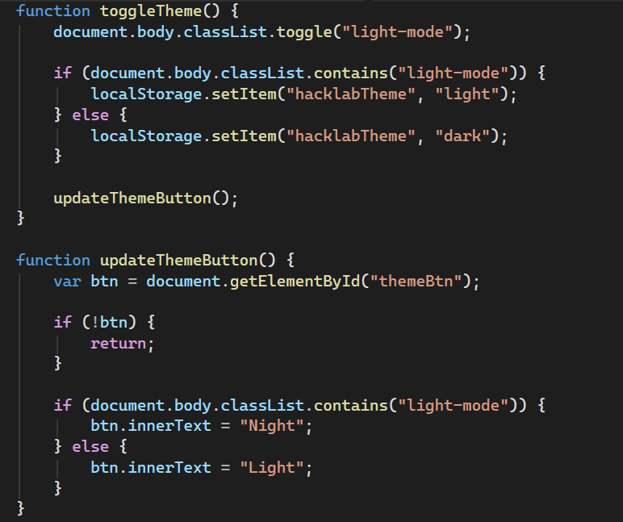
Figure 18 The toggleTheme() function handles dynamic light-and-dark theme switching

4.1.4 Contact Page Layout
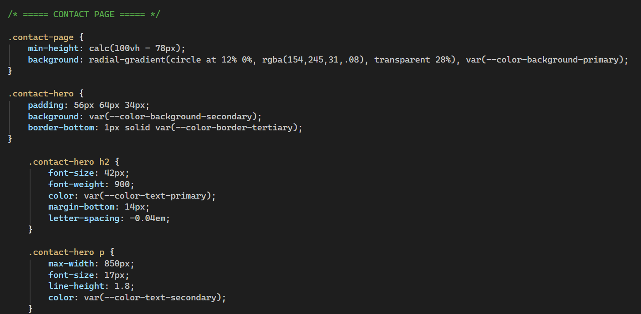
Figure 19 shows clean layout styling for the contact form.

4.2 Form Validation

4.2.1 Registration.aspx
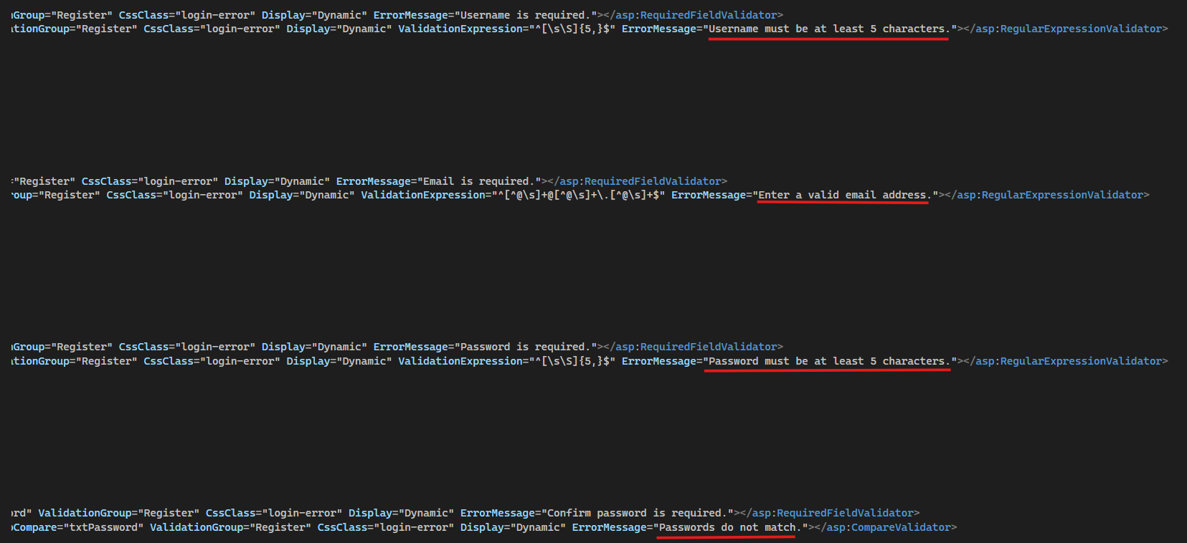
Figure 20 ASP.NET declarative validators displaying real-time error messages
Each field in the registration.aspx has a RequiredFieldValidator. Username and Password also have a RegularExpressionValidator enforcing a minimum length of 5 characters. The CompareValidator cross-checks Password against Confirm Password, and a ValidationSummary displays all errors in one place.
After the ASP.NET validators pass, the code-behind enforces additional rules that require database lookups: uniqueness of username and email. A MailAddress parse confirms email format on the server.
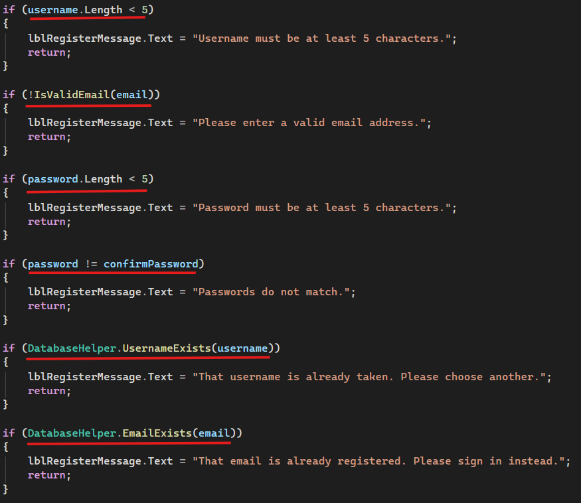
Figure 21 Server-side C# validation logic enforcing username length and email verification

4.2.2 Login.aspx
The login form uses two RequiredFieldValidators (one per field). All credential verification runs server-side. If credentials are invalid, a generic error is shown that does not reveal whether the username or password was wrong.
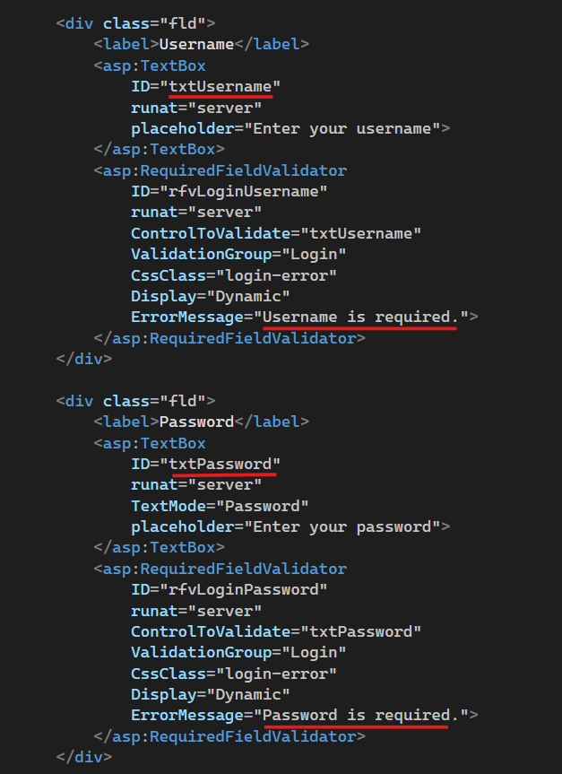
Figure 22 ASP.NET RequiredFieldValidators displaying a generic error message for invalid login credentials
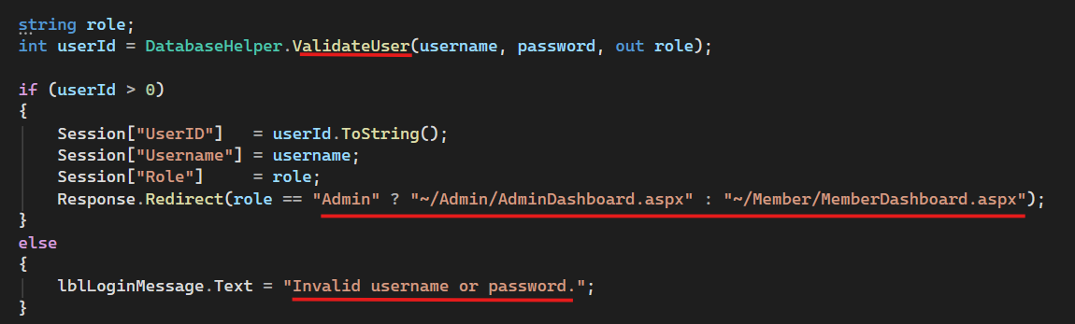
Figure 23 Server-side authentication logic verifying credentials against the database and routing the authenticated user to their designated dashboard.

4.2.3 ForgetPassword.aspx
The password-reset flow validates username (min 5 chars), new password (min 5 chars), confirms the two password fields match and checks if the given username exists in the database.
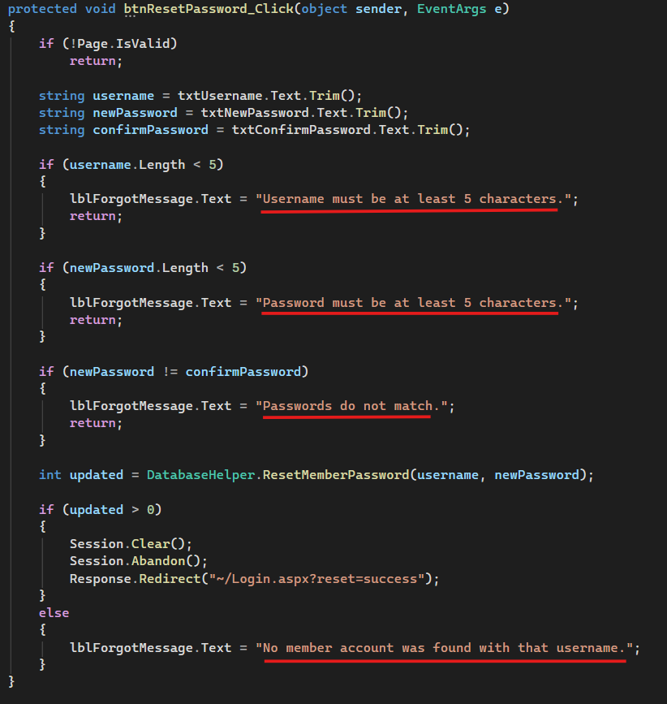
Figure 24 Server-side C# validation and reset logic enforcing character length requirements and checking password alignment

4.3 SQL Queries
DatabaseHelper.cs is the single centralized data-access layer for the entire application. It is a static class that wraps ADO.NET's SqlClient. Every query in the project goes through this file, no other code-behind file opens its own SqlConnection directly except MemberDashboard.aspx.cs which uses a direct SqlDataReader to demonstrate raw ADO.NET usage as required by the project specification.

4.3.1 Web.config
The connection string is stored in Web.config and read at runtime via Configuration Manager. This means no credentials are hard-coded in C# source files.
Figure 25 Web.config file configuration establishing the centralized database connection
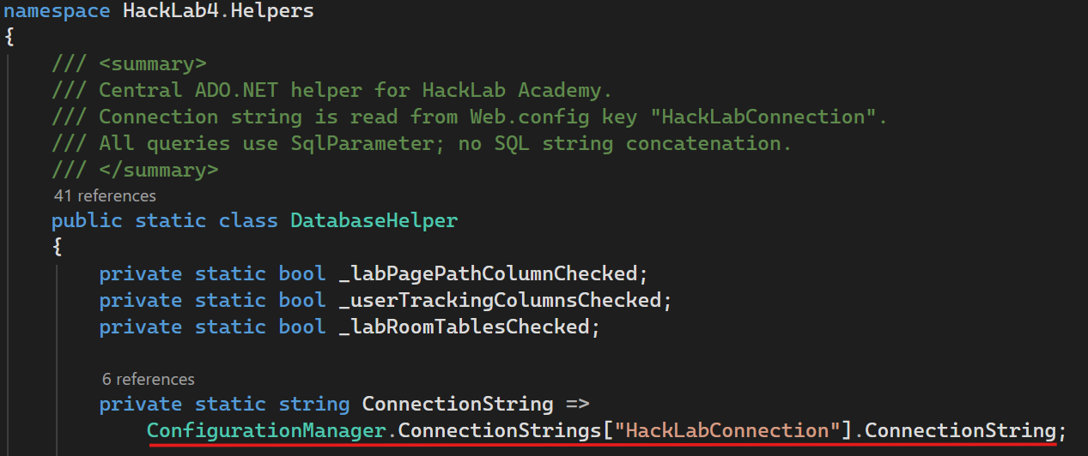
Figure 26 Centralized ADO.NET database connectivity method in DatabaseHelper.cs

4.3.2 Core Execution Helpers
Four low-level methods: ExecuteNonQuery(), ExecuteInsertAndGetId(), ExecuteScalar() and GetDataTable() wrap ADO.NET in using blocks to guarantee connection disposal. All accept a params SqlParameter[] array, so every caller passes type-safe parameters and never string concatenation.
1. ExecuteNonQuery(): INSERT / UPDATE / DELETE returns rows affected.
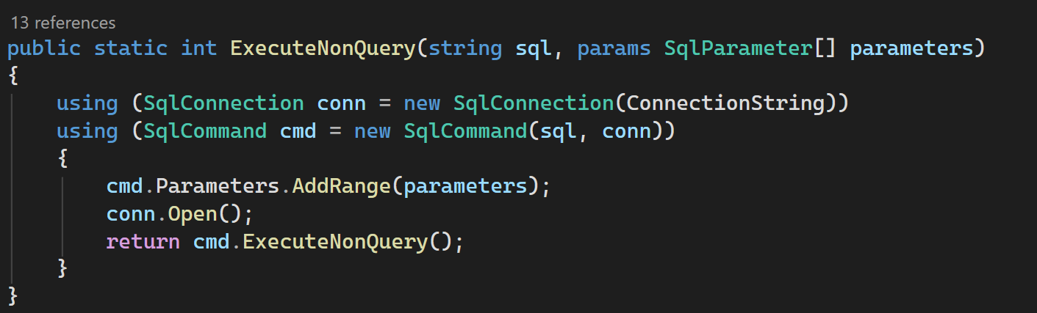
2. ExecuteInsertAndGetId(): INSERT + SELECT SCOPE_IDENTITY() returns new PK as int.
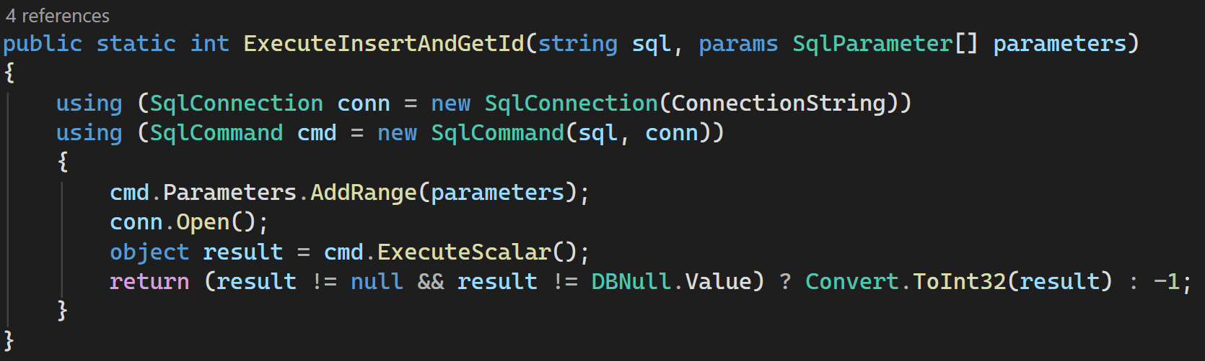

3. ExecuteScalar(): Returns a single value (COUNT, exists check, etc.)
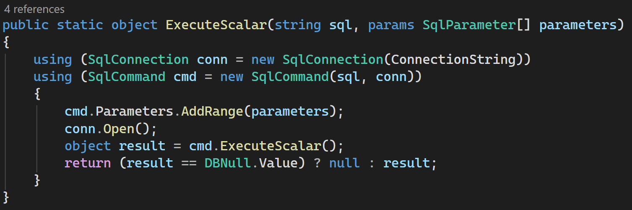
4. GetDataTable(): Fills and returns a DataTable via SqlDataAdapter
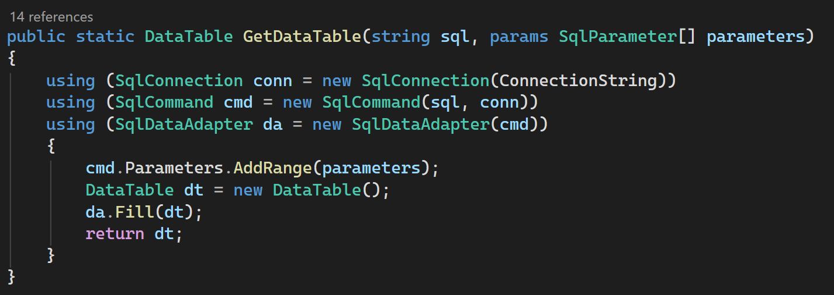

4.3.3 User Management SQL queries
User Registration - RegisterUser()
Inserts a new Student account. The password is hashed with PBKDF2 before being stored. SELECT SCOPE_IDENTITY() returns the new UserID in the same round-trip.
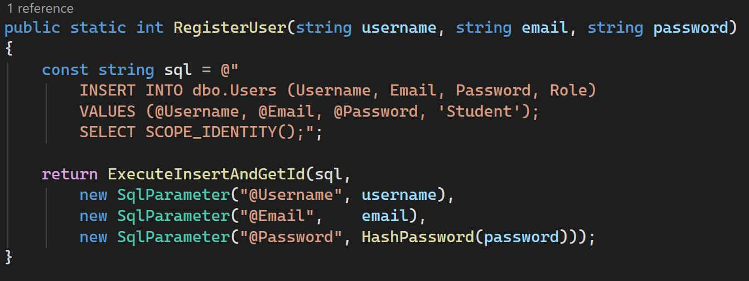
Login Validation - ValidateUser()
Retrieves the stored hash for the given username. Password verification runs in C# (PBKDF2 comparison) rather than SQL to keep hashing logic server-side. A successful login triggers RecordSuccessfulLogin() which updates LastLoginAt and increments LoginCount.
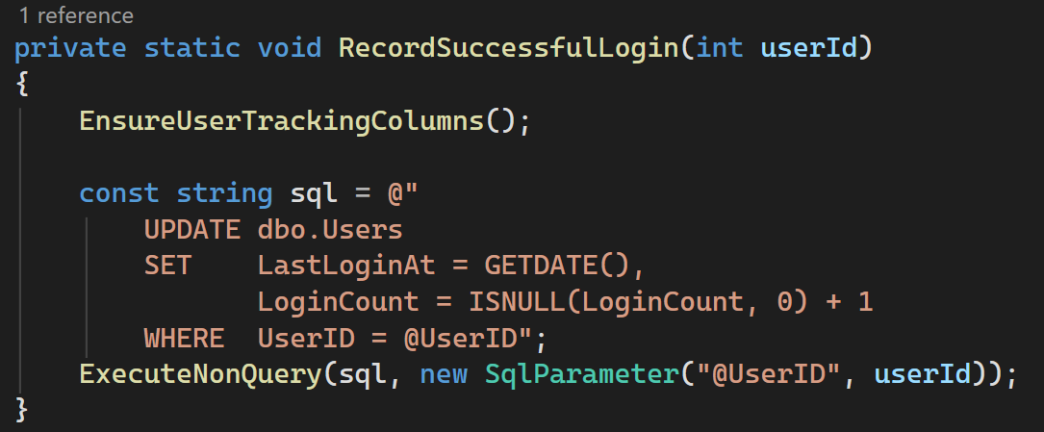

Duplicate Checks - UsernameExists() / EmailExists()
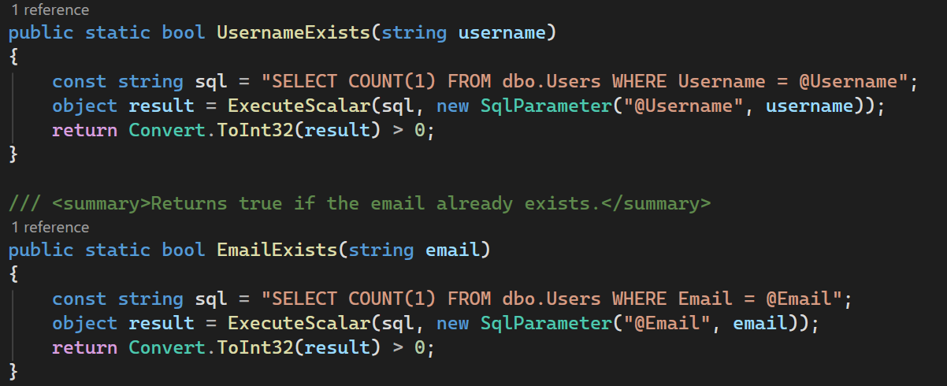
Forgot Password - ResetMemberPassword()
The Forgot Password page allows a Student to set a new password by username.
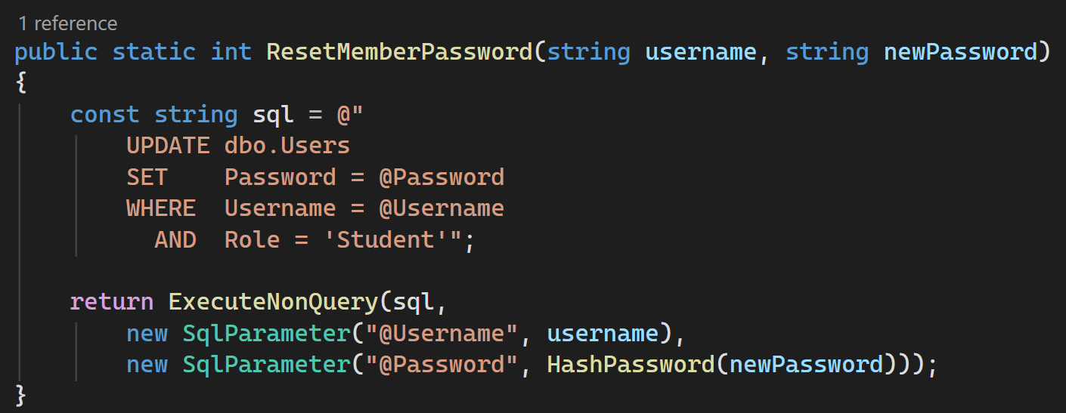

Query to View All Labs - GetAllLabs()
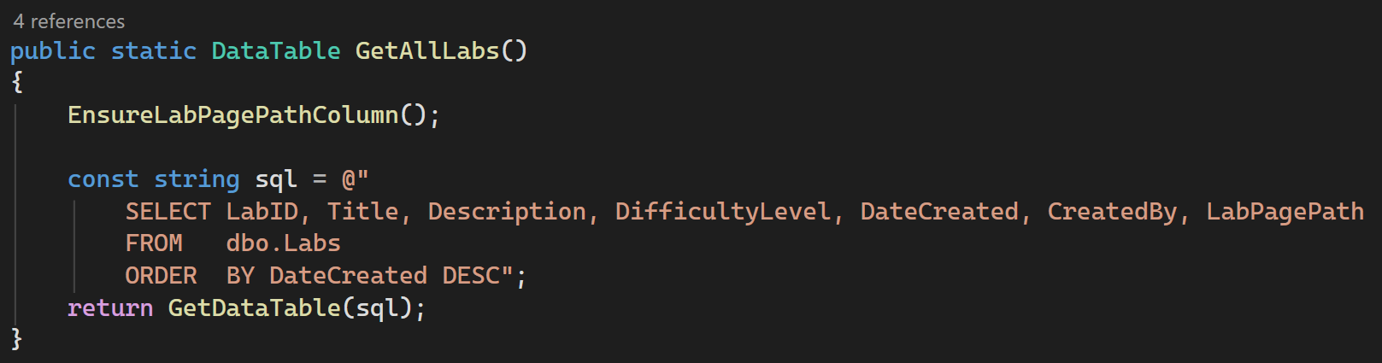
Query to Add Labs - AddLab()
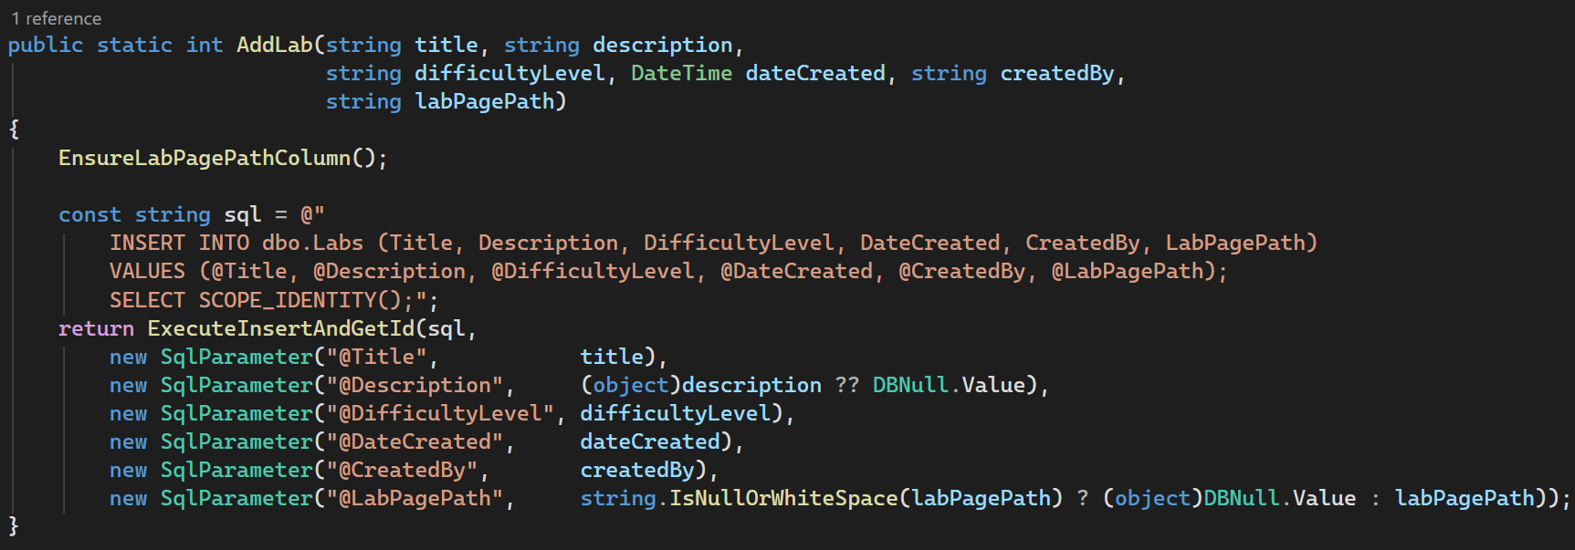
Query to Update Labs – UpdateLab()
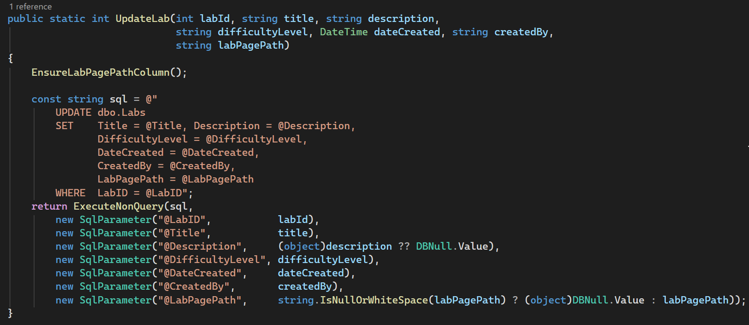
Query to Delete Labs – DeleteLabs()
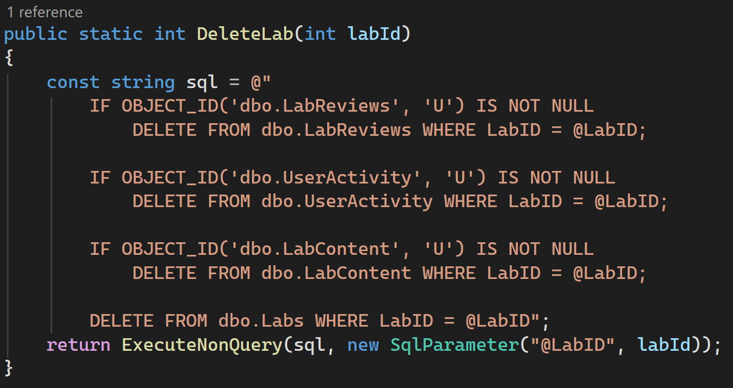
Query to Search Labs - SearchLabs()
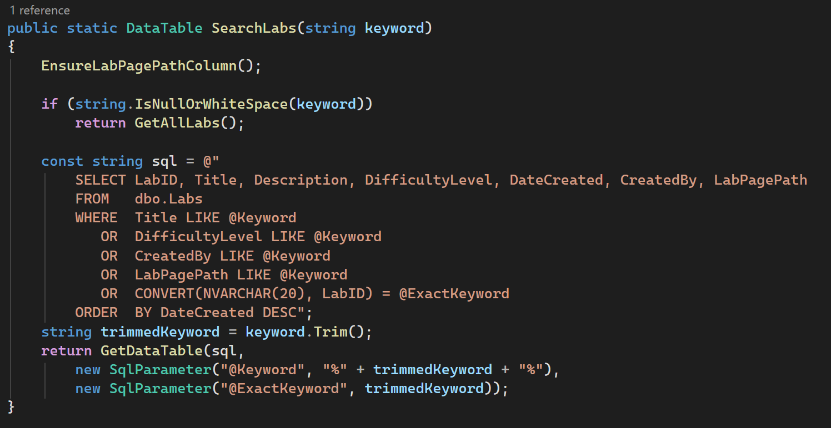

CHAPTER 5: USER GUIDANCE

5.1 Homepage - Home.aspx
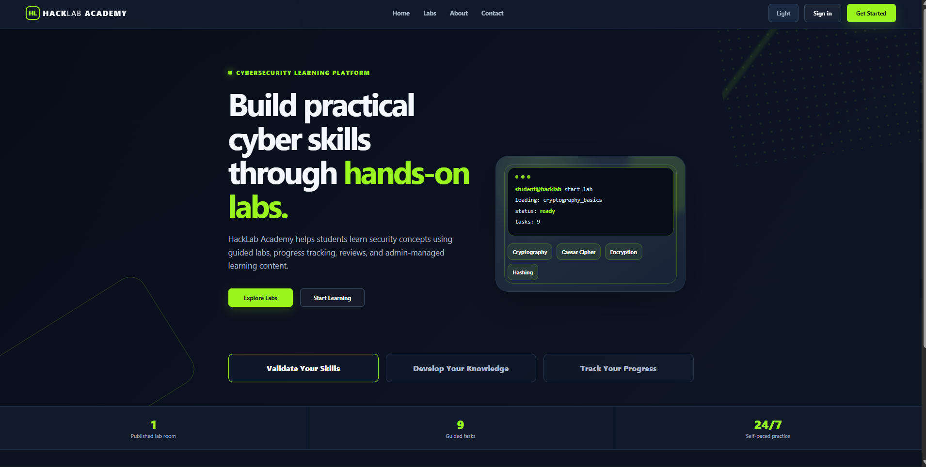
Figure 27 Hack Lab Academy homepage interface showcasing the public cybersecurity training modules, introductory learning resources, and guest navigation entry paths.

5.2 About Us Page – About.aspx
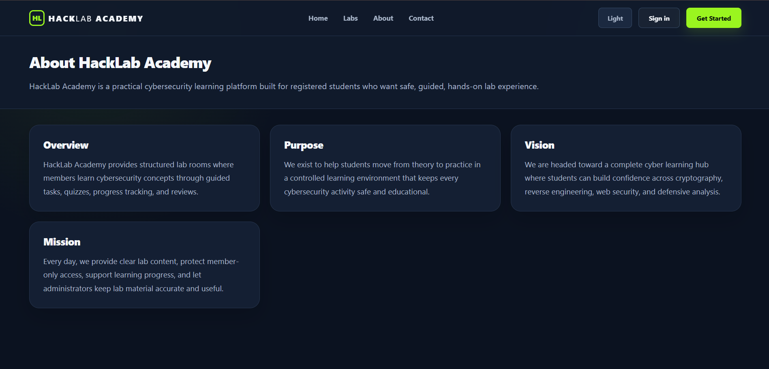
Figure 28 HackLab Academy About Us interface detailing the platform's core mission statement, foundational goals, and development team profile.

5.3 Contact Us Page – Contact.aspx
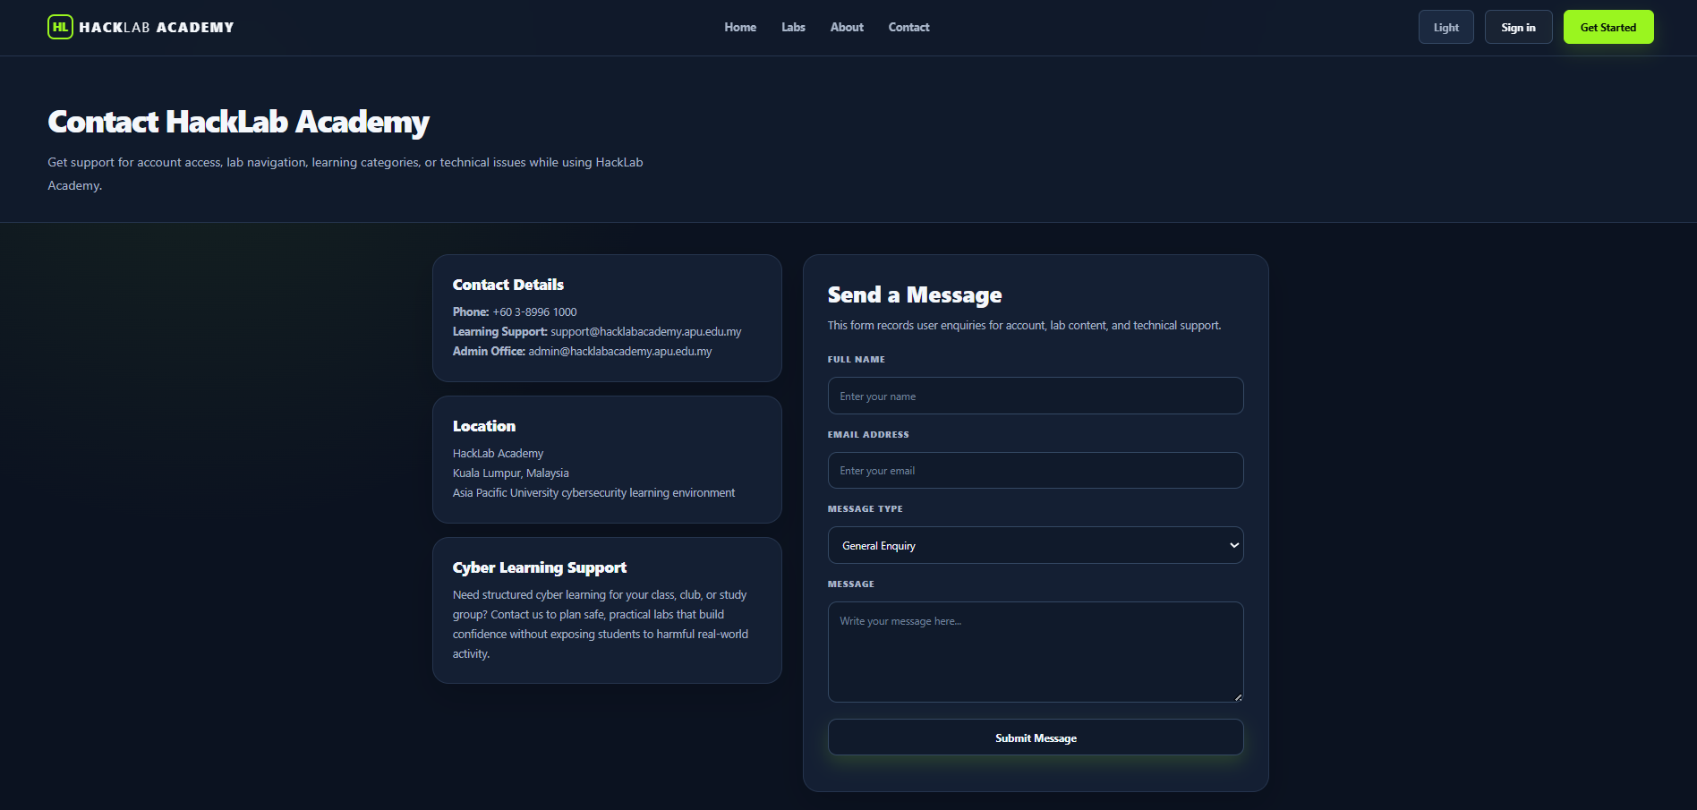
Figure 29 HackLab Academy Contact Us interface featuring an integrated inquiry form with input validation for user messages and feedback submissions.

5.4 Registration Page – Register.aspx
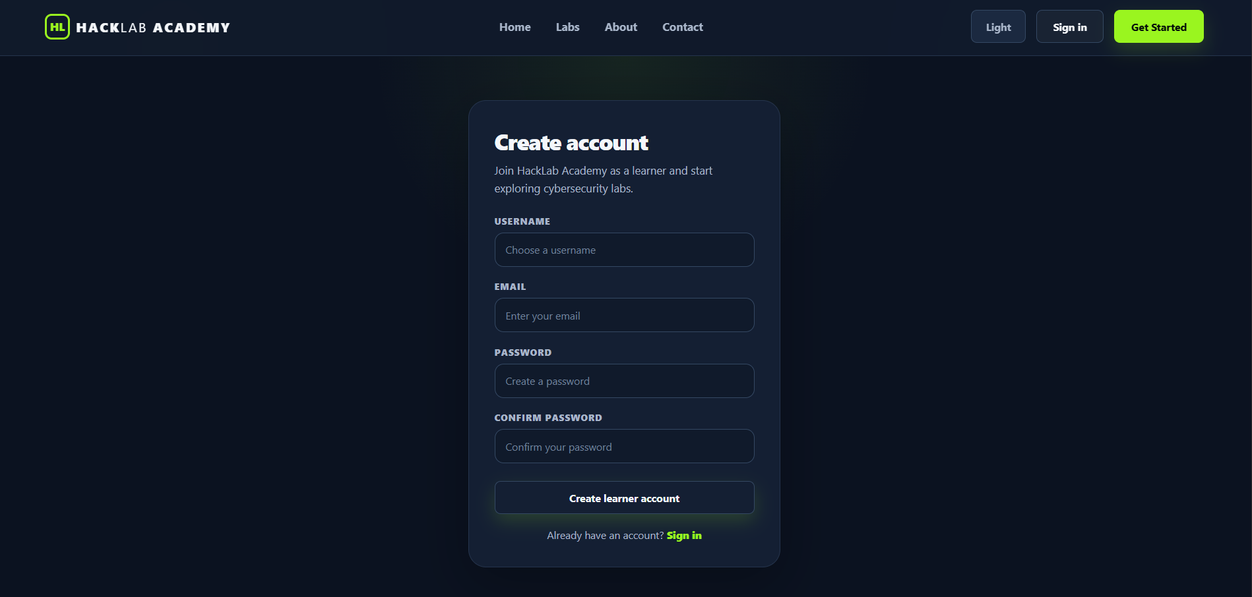
Figure 30 HackLab Academy Registration interface providing a secure account creation form equipped with real-time field validation for new students.

5.5 Login Page – Login.aspx
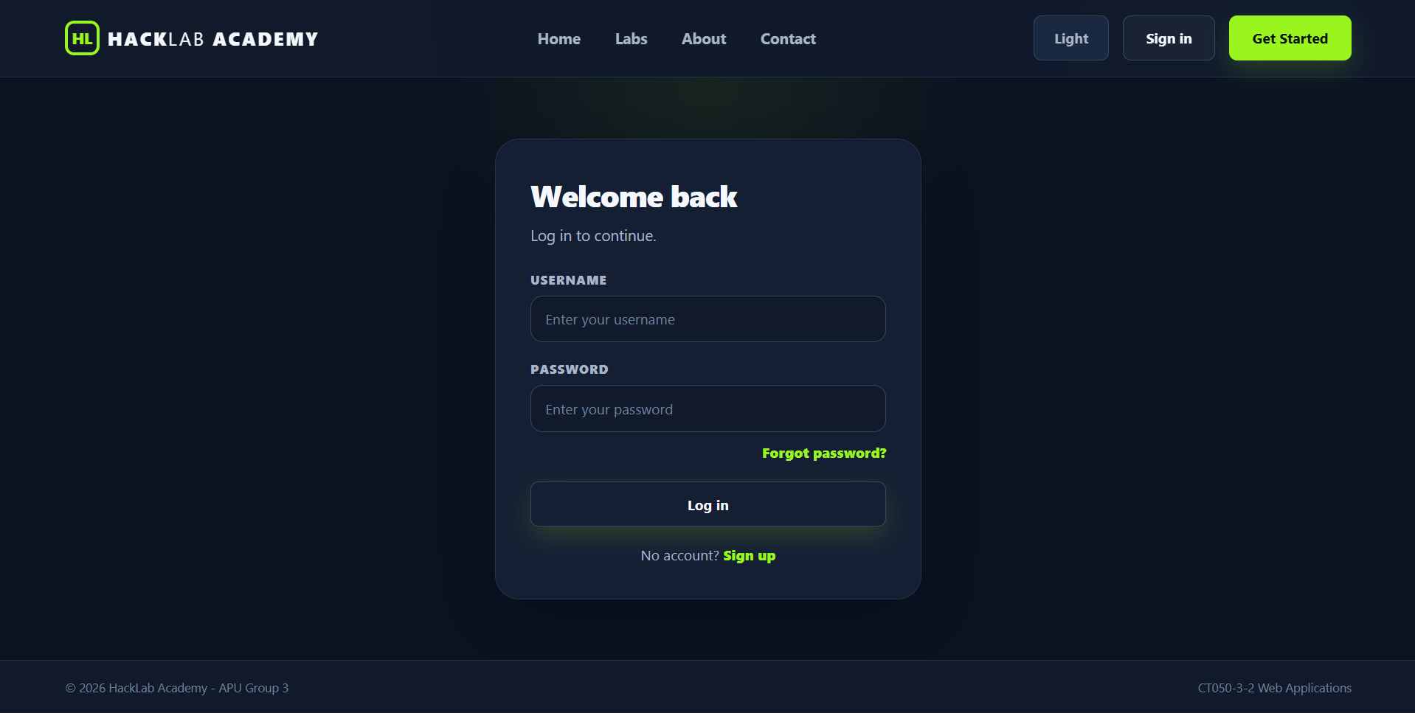
Figure 31 HackLab Academy Login interface featuring a secure credential entry form for authenticated student and administrator dashboard access.

5.6 Password Reset Page – ForgetPassword.aspx
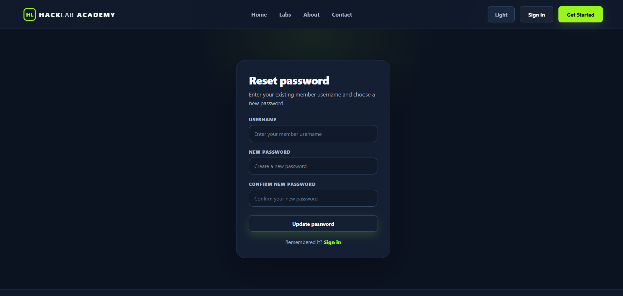
Figure 32 HackLab Academy Reset Password interface allowing students to securely update their account credentials using an identity-verified recovery form.

5.7 Member Dashboard Page – MemberDashboard.aspx
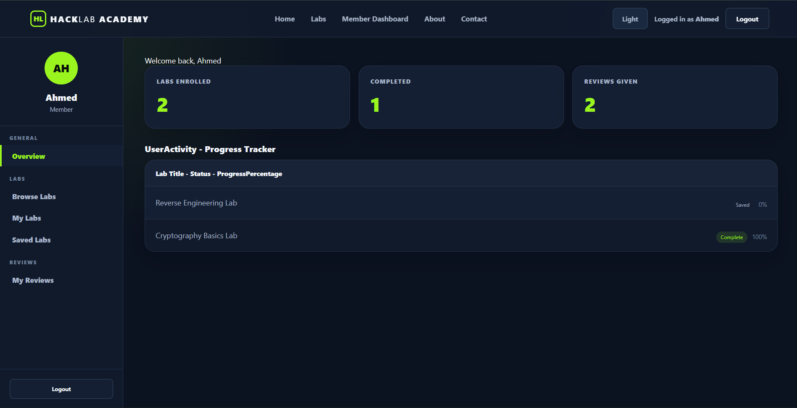
Figure 33 HackLab Academy Member Dashboard interface showcasing student learning metrics, enrolled cybersecurity labs, and real-time progress tracking indicators.

5.8 Reverse Engineering Lab - ReverseEngineeringLab.aspx
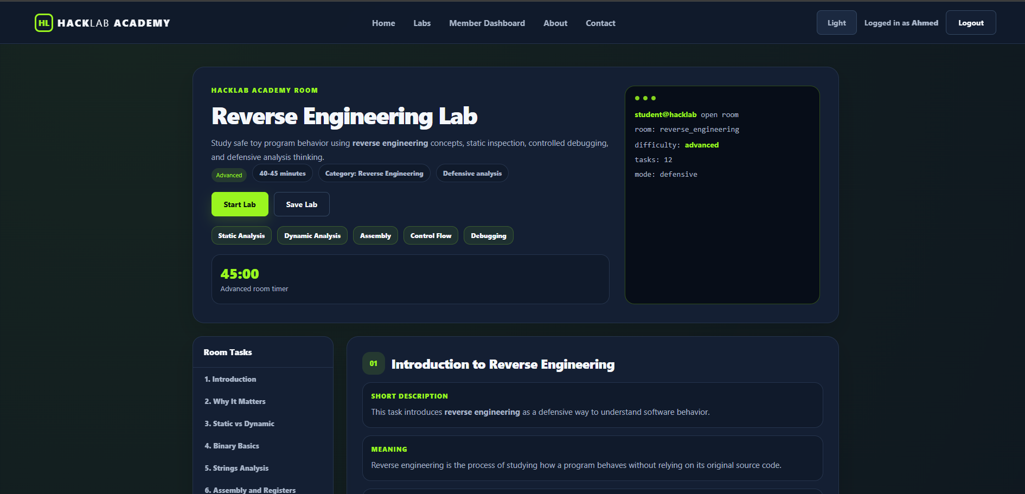
Figure 34 HackLab Academy Reverse Engineering Lab room interface providing interactive practical hacking challenges, structured technical documentation, and real-time answer verification.

5.9 Cryptography Lab – Cryptography.aspx
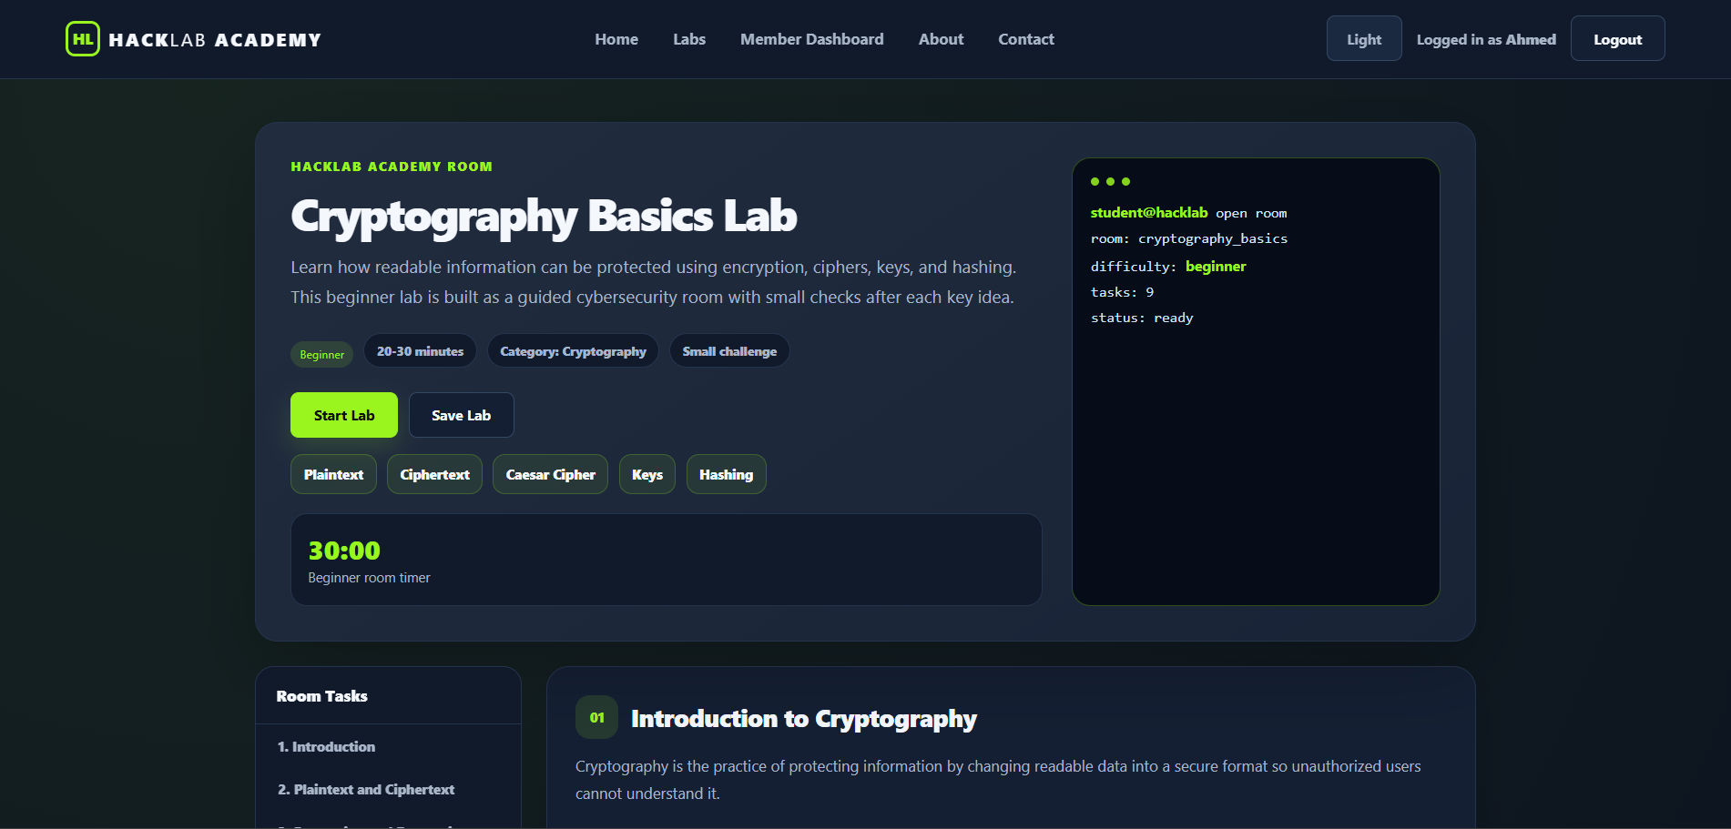
Figure 35 HackLab Academy Cryptography Lab room interface providing interactive code-breaking challenges, foundational encryption documentation, and real-time validation

5.10 Admin Dashboard page – AdminDashboard.aspx
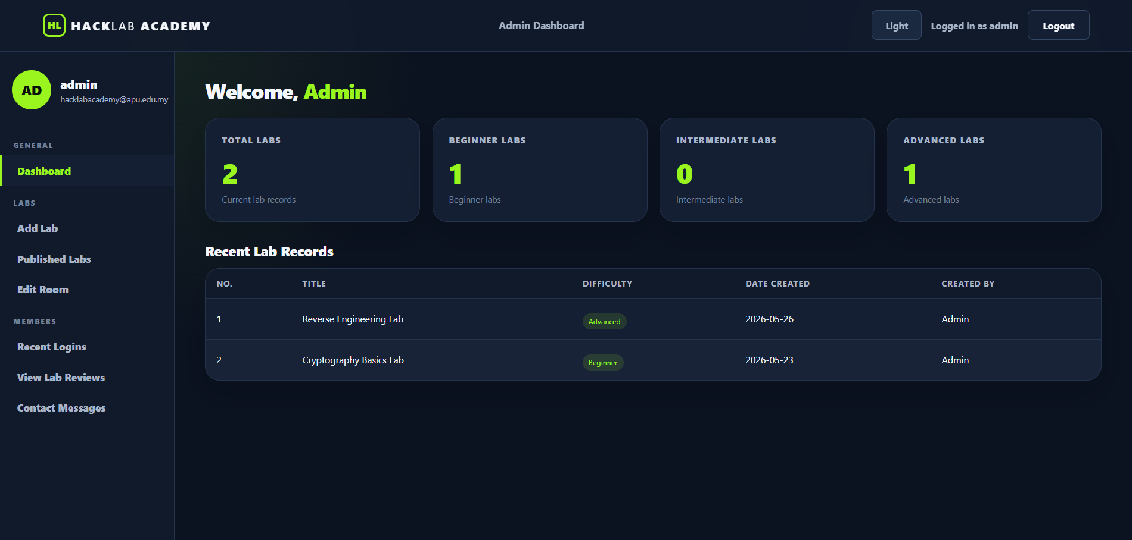
Figure 36 HackLab Academy Admin Dashboard interface featuring central database CRUD management controls, user activity tracking grids, and administrative laboratory configuration panels.

5.11 Add / Publish Lab page
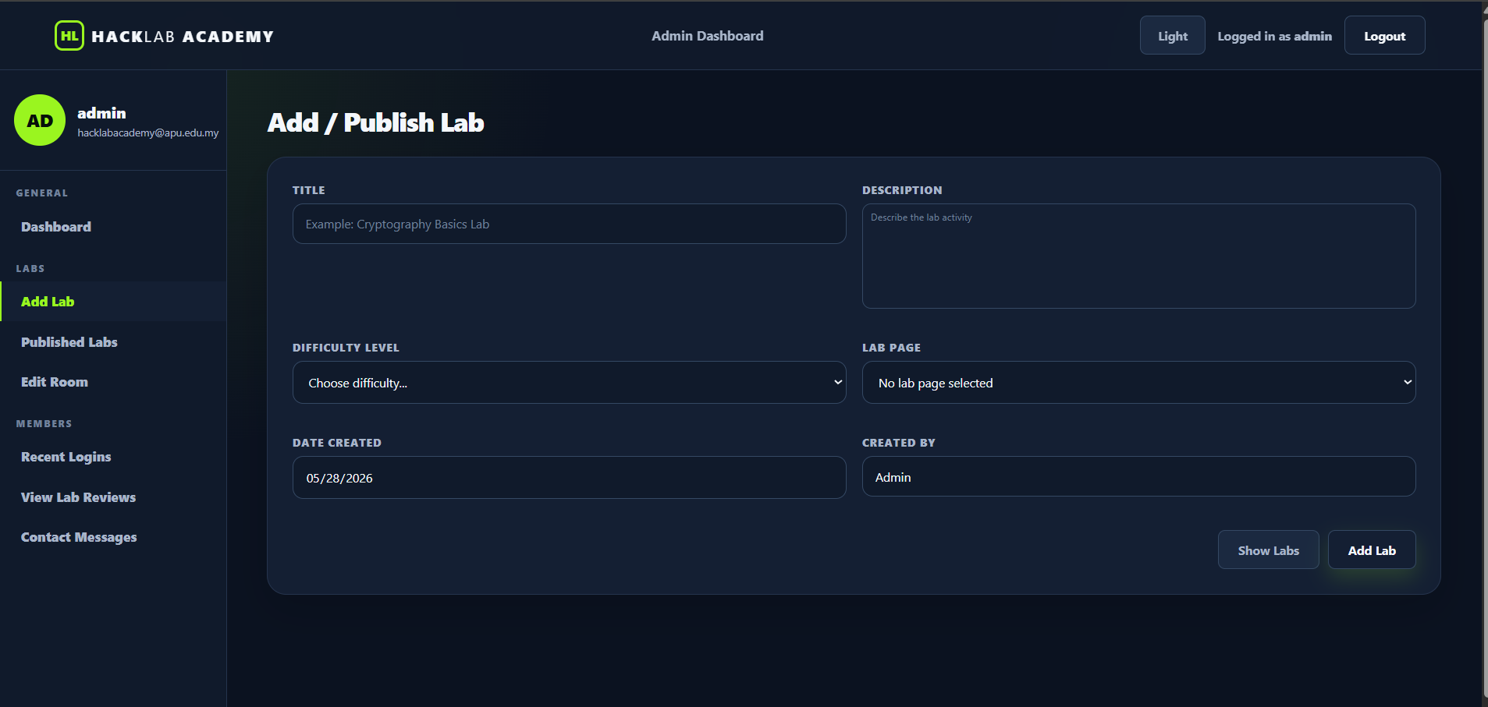
Figure 37 HackLab Academy Add/Publish Lab interface allowing administrators to securely input technical challenge parameters and dynamically instantiate new laboratory modules within the database.

5.12 Published Labs page
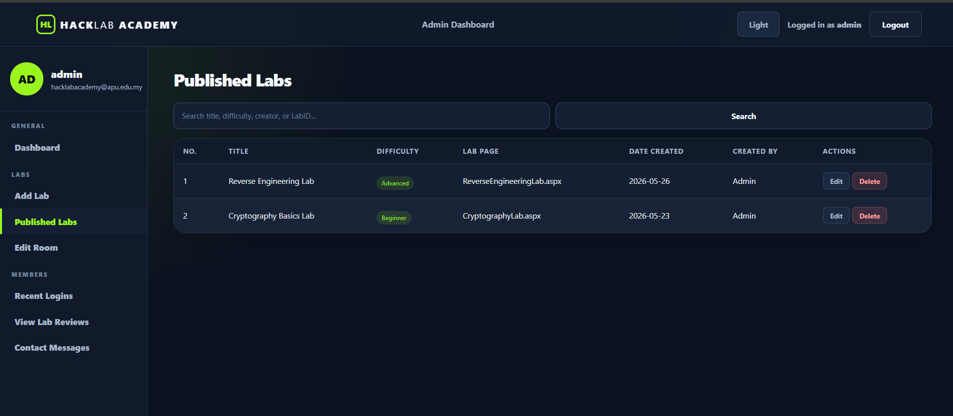
Figure 38 HackLab Academy Published Labs interface featuring a tabular management grid for tracking, editing, and deleting active cybersecurity laboratory modules.

5.13 Edit Room Content page
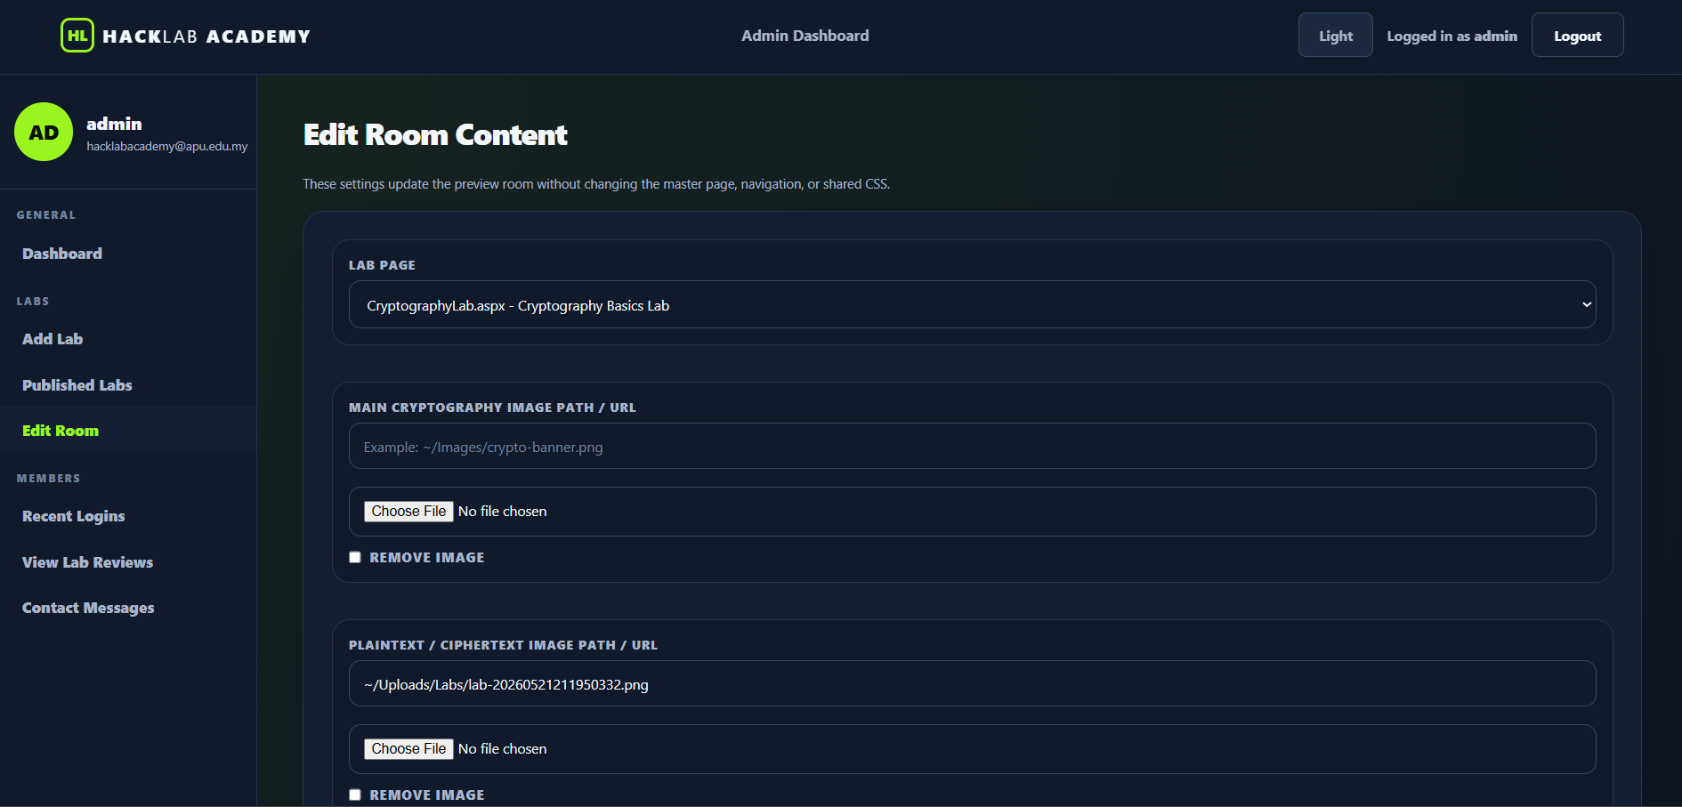
Figure 39 HackLab Academy Edit Room Content interface allowing administrators to update specific challenge layout details, map asset file paths, and dynamically modify media configurations for active laboratory rooms.

5.14 Recent Member Logins
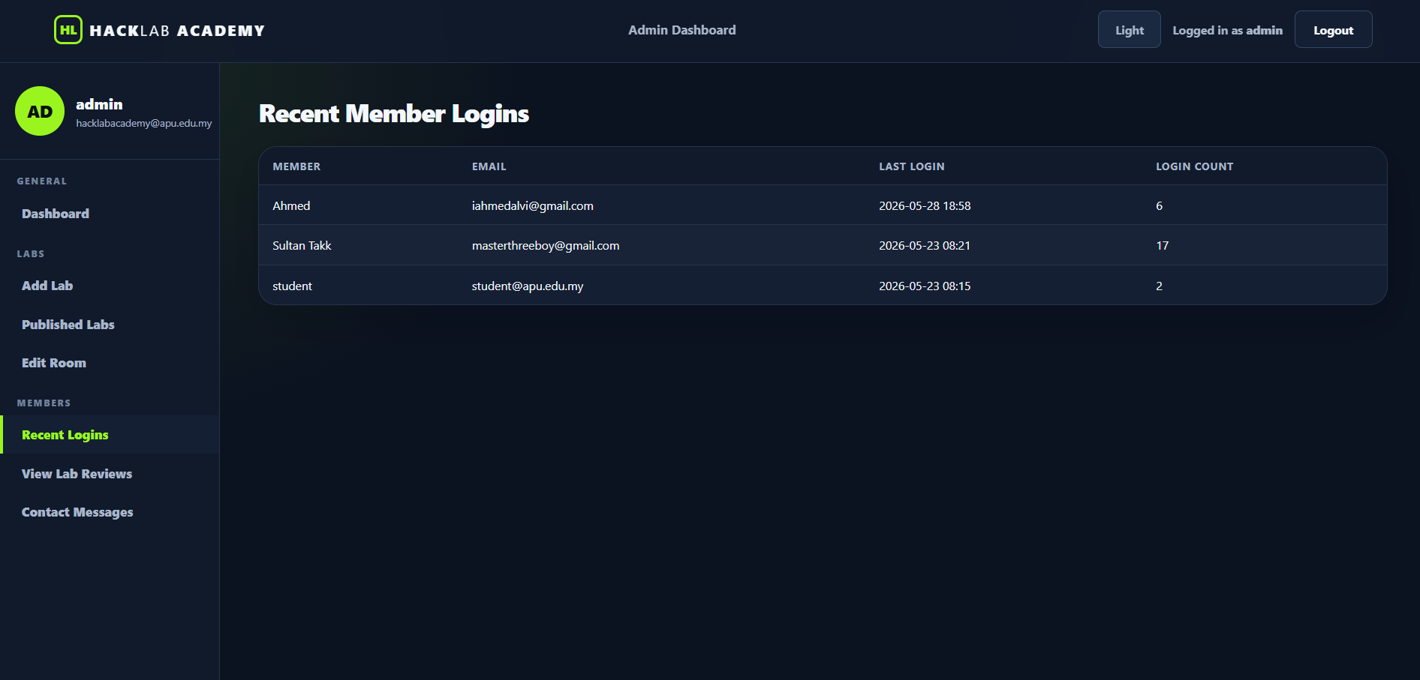
Figure 40 HackLab Academy Recent Member Logins interface featuring a tabular tracking grid that displays user email addresses, historical login timestamps, and aggregate entry frequencies for administrative user auditing.

5.15 View Lab Reviews page
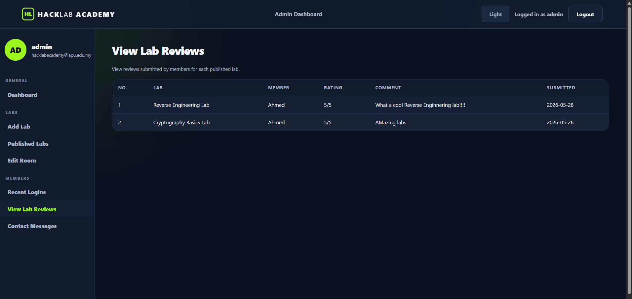
Figure 41 HackLab Academy View Lab Reviews interface featuring a central tabular grid that displays student-submitted laboratory feedback, numeric ratings, and evaluation comments for administrative quality monitoring.

5.16 Contact Messages page
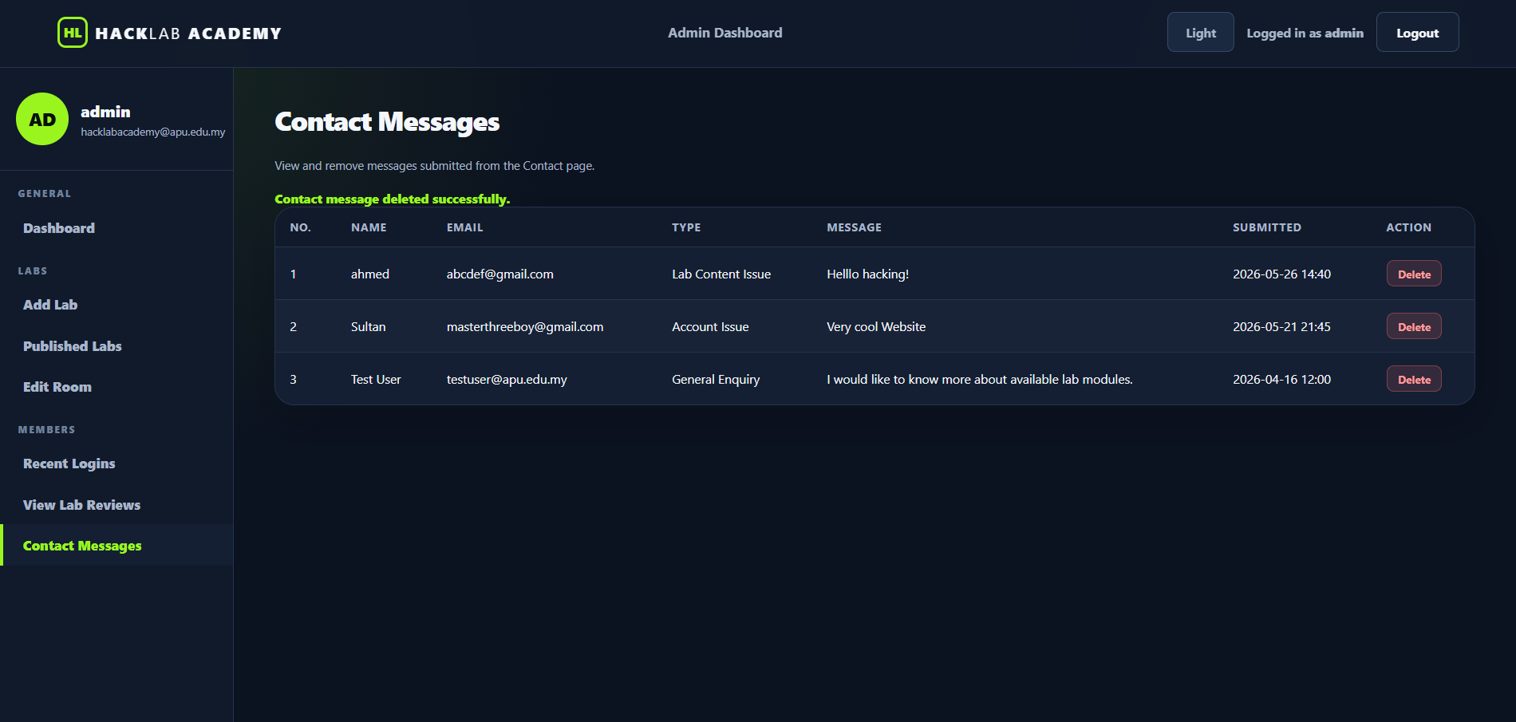
Figure 42 HackLab Academy Contact Messages interface featuring a central tabular grid to review and delete user-submitted inquiries, complete with message categorizations, timestamps, and real-time deletion feedback for administrative moderation.

CONCLUSION
In conclusion, HackLab Academy was successfully developed as a web-based cybersecurity learning platform that provides students, beginners, and self-learners with an interactive and practical learning environment. The system includes important features such as user authentication, role-based access, virtual labs, quizzes, progress tracking, and administrative management tools. Through the implementation of ASP.NET, HTML5, CSS, JavaScript, and MS SQL Server, the project achieved its objective of creating a secure and user-friendly educational platform.
Throughout the development process, several valuable lessons were learned in both technical and teamwork aspects. The project improved our understanding of web application development, database connectivity, form validation, and secure authentication methods. We also gained practical experience in system analysis, interface design, SQL query handling, and debugging. In addition, collaboration within the group enhanced our communication, planning, and problem-solving skills while working on a real-world cybersecurity-related project.
For future enhancements, HackLab Academy can be improved by adding advanced cybersecurity lab simulations, real-time Capture The Flag (CTF) competitions, and AI-based personalized learning recommendations. Additional features such as cloud hosting, two-factor authentication, discussion forums, and mobile responsiveness can further improve accessibility, security, and user engagement. These improvements would help the platform provide a more advanced and scalable cybersecurity learning experience.

REFERENCES

Abuhakmeh, K. (2020, June 5). Basics of ADO.NET. Retrieved from JETBRAINS: https://www.jetbrains.com/guide/dotnet/tutorials/basics/ado-net/
Creately. (2023, January 5). Use Case Diagram Guidelines for Better Use Cases. Retrieved from Creately: https://creately.com/blog/software-teams/use-case-diagram-guidelines/
GeeksforGeeks. (2025, July 11). Introduction to ASP.NET. Retrieved from GeeksforGeeks: https://www.geeksforgeeks.org/c-sharp/introduction-to-asp-net/
Guilizzoni, P. (2025, May 8). What is a wireframe? A guide for non-designers. Retrieved from Balsamiq: https://balsamiq.com/blog/what-are-wireframes/
ITC Group. (2024, December 30). Why C# for Web Development is A Great Choice? Retrieved from ITC Group: https://itcgroup.io/our-blogs/why-c-for-web-development-is-a-great-choice/
Khan, S. A. (2024, November 12). What is HTML? Retrieved from Medium: https://medium.com/diary-of-a-software-developer/what-is-html-41132db453c2
Paul Kirvan, K. T. (2025, October 14). What is an entity relationship diagram (ERD)? Retrieved from TechTarget: https://www.techtarget.com/searchdatamanagement/definition/entity-relationship-diagram-ERD
Staff, C. (2025, September 24). What Is JavaScript Used For? Retrieved from Coursera: https://www.coursera.org/articles/what-is-javascript-used-for
Team, I. E. (2025, December 11). What Is CSS? (And Why It’s Important). Retrieved from Indeed: https://www.indeed.com/career-advice/career-development/what-is-css

APPENDIX: PROPOSAL REPORT
Title:
Hack Lab Academy – Virtual Cybersecurity Learning Platform
Mission Statement:
The goal of Hack Lab Academy is to develop a web-based cybersecurity learning platform that provides structured educational content, virtual labs, and ethical hacking exercises for students, beginners, and self-learners. The platform focuses on cybersecurity topics such as cryptography, reverse engineering, and Capture The Flag (CTF) challenges. Its purpose is to create a safe and interactive learning environment where users can improve their cybersecurity knowledge and practical skills through guided activities and role-based learning features.
OBJECTIVES:
- To conduct a preliminary and feasibility study for the development of Hack Lab Academy.
- To gather information about user requirements, cybersecurity learning needs, and system functionality.
- To analyze the technical and functional requirements of the platform, including security, usability, and accessibility.
- To construct requirement models and define user roles, system processes, and database requirements.
- To design the website interface, system architecture, navigation structure, and database model.
- To build and develop the platform using HTML5, CSS, JavaScript, ASP.NET, and MS SQL database technologies.
- To implement features such as login systems, course modules, quizzes and virtual labs
- To evaluate and test the system for functionality, usability, security, and overall performance.
- To maintain and improve the platform through updates, technical support, and content management.

WORKLOAD MATRIX
Group Number: 03
Name | Web Forms or Pages Created (Filenames) | Data Connectivity and Processing | Signature
1. Sultan Abdulla Omar Takrori (TP085327) |  |  | STK
2. Mohamed Abdifatah Ali (TP082459) |  |  | 
3. Ahmed Mirahusain Alvi (TP084807) |  |  | 
4. Alaa Ahmed Mohamed Abdelhai (TP084446) |  |  | 

